MPM1D – Spheres Practice
$$V=\frac{4πr^{3}}{3}$$

$$SA=4πr^{2}$$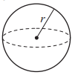
- a) Calculate the surface area and volume of the sphere. Show your work.
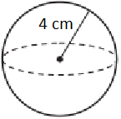
- a) A sphere fits tightly into a box. What is the volume of the sphere?
b) How much air is in the box? Show your work.
