MPM1D – Pyramids Learning Check
$$V=\frac{b^{2}h}{3} \\ SA=b^{2}+4\frac{bs}{2}$$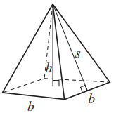
- a) Calculate the volume of the pyramid. Show your work.
- Find the slant height. Show your work.
- Calculate the surface area of the pyramid. Show your work.
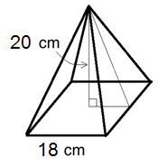

MPM1D – Pyramids Learning Check
$$V=\frac{b^{2}h}{3} \\ SA=b^{2}+4\frac{bs}{2}$$
- a) Calculate the volume of the pyramid. Show your work.
- Find the slant height. Show your work.
- Calculate the surface area of the pyramid. Show your work.

