MPM1D – FORMULA SHEET FOR PLAYDOH, WATER AND PAPER QUESTIONS
SHAPE | PERIMETER | AREA
Circle | 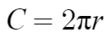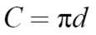 | 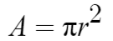
Square | 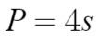  (s is side length of square) | 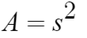
SHAPE | SURFACE AREA | VOLUME
Sphere | 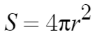 | 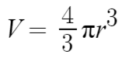
Cylinder | 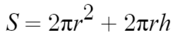 | 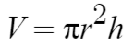
Cube | 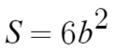  (b is side length of cube) | 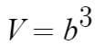
Square-based prism | $$S=2wl+2wh+2lh$$ | $$V=b^{2}h$$

