Find the area and perimeter of the following shapes. Show all important calculations.

Example 1

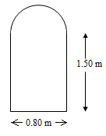

# Example 2

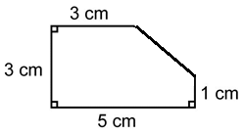

**Past EQAO Question**

