MPM1D – Cones Practice
$$V=\frac{{πr}^{2}h}{3}$$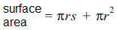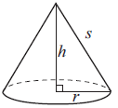
- a) Calculate the volume of the cone. Show your work
b) Use the radius and height to find the slant height of the cone
c) Calculate the surface area of the cone. Show your work.
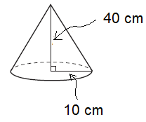
- a) Use the slant height and radius to calculate the height of the cone. Show your work.
b) Calculate the volume of the cone.
