MPM1D – Optimizing Dimensions Name: _______________
DAYCARE FENCE
A daycare is putting up a fence to enclose the children. It has budgeted enough for 72m of fence. What length and width will give it the biggest area?
For this fence arrangement, write an equation to calculate:
a) the amount of fence used:
b) the area of the rectangle:
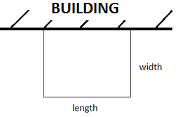
Fence Used (m) | Length | Width – use your equation above | Area
72 m | 5
72 m | 10
72 m | 15
 | 20
 | 25
 | 30
 | 35
 | 40
 | 45
 | 50
 | 55
Now make a graph with the length on the x-axis and area on the y-axis…
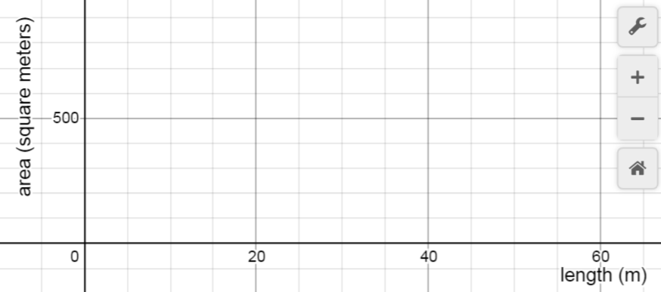
- Which length and width in your table on the front side of the page gave the biggest area?

- Now draw a smooth curve of best fit on your scatterplot. Mark a point at the place that appears to have the largest possible area. State the coordinates of the point, and explain the meaning of the coordinates.

- Is it possible that your length from question #1 above is not the absolute best? Remember that the table was going up by 5. Spend some time to try to determine the length that gives the very biggest area. Summarize your findings in the boxes below.
For this particular fence configuration, what is the ratio of length to width that gives the maximum area?
Optimal Dimensions (length/width) and Max Area:

- Suppose a different daycare had a larger budget, and could afford 108 m of fence. What are the dimensions (length and width) that will give the maximum area? What is the area? Show your work.

PIGPENS
A farmer needs to put up some fencing to hold her pigs in two separate areas (see diagram). If the total area needs to be 588 feet², what is the smallest amount of fence, to the nearest foot, that the farmer needs? 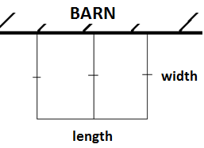
For this fence arrangement, write an equation to calculate:
a) the area:
b) the total amount of fence used:
Area (feet²) | Length (ft) | Width (ft) | Fence used (feet)
588 | 20
588 | 25
588 | 30
 | 35
 | 40
 | 45
 | 50
 | 55
 | 60
 | 65
 | 70
Now make a graph with the length on the x-axis and fence used on the y-axis…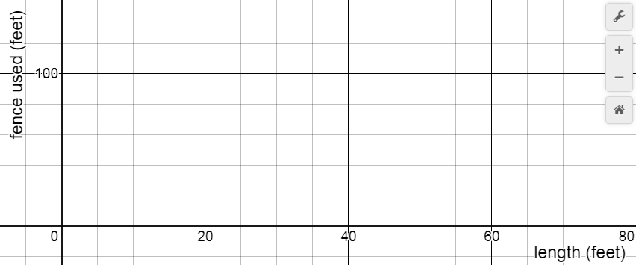
- Which length and width in your table on the front side of the page gave the smallest amount of fence used?

- Now draw a smooth curve of best fit on your scatterplot. Mark a point at the place that appears to have the smallest amount of fence used. State the coordinates of the point and explain the meaning of the coordinates.

- Is it possible that your length from question #1 doesn’t give the absolute smallest amount of fence? Remember that the table was going up by 5. Spend some time to try to determine the length that gives the smallest amount of fence used. Summarize your findings in the boxes below.
For this particular fence configuration, what is the ratio of length to width that gives the minimum fence used?
Optimal Dimensions (length/width) and Minimum Fence Used:
- Suppose a different farmer needed an area of 800 square feet for her pigs and chickens. What are the dimensions (length and width) that will give the minimum amount of fencing? Note: they are still building the same shapes as the front side of the page. Feel free to use trial and error (although there is an algebraic way…)
Daycare follow up questions…
A daycare is allowed to have a maximum of 3 children for every 12m² of enclosed play area. Each child at the daycare pays $850/month in fees.

- A daycare has 72 m of fence to build according to the diagram above. What is the maximum amount of money that the daycare could earn per month? Use the results of the investigation. Show your work.
- The daycare decides to build their yard with a width of 24m and a length of 24m. How much less money are they earning than what they could be? Show your work.
- If the daycare had 120m of fence instead of 72m, what is the maximum number of students they could enclose? Show your work.
- If the most that another daycare can earn is $22 100 per month, what were the dimensions of the yard, and how much fence did they build with? Show your work.

Farmer follow up questions…
The farmer calls the fencing company, and they can install it for $75/meter. Pig food costs $20 for a 50 kg bag.

- What is the smallest amount of money that the farmer can spend on his animal fencing? (Remember, it must have an area of 588 feet²). Use the results of your investigation, and show your work.
- Farmer 1 builds her fence using the optimal dimensions, but Farmer 2 builds his fence in the shape of a square (with one side still against the barn). Both farmers still have an area of 588 feet². How many extra kg of pig food will Farmer 1 be able to afford due to her superior fence design? Show your work.
- If the farmer needed to enclose 2000 feet² instead of 588 feet², what is the minimum cost of the fence? You need the ratio of length to width to reflect the results of your investigation. Show your work.
- If a farmer’s fence cost $6000, what were the fence dimensions? Assume it was built to minimize the amount of fence used.

SKATING RINK
The city off Ottawa is building two ice skating rinks, side by side, as shown in the diagram. It can afford to build boards with a total length of 500 feet. What is the biggest total skating rink area that it can enclose? Find your answer to the nearest foot.
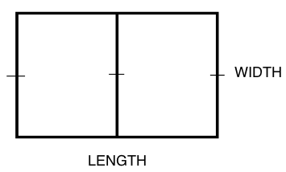
Fence Used | Length | Width | Area

EX3 Skating rink follow up questions…
For this particular fence configuration, what is the ratio of length to width that gives the maximum area?
Optimal Dimensions and Maximum Area?
The city is allowed 4 skaters for every 100 square feet of skating area. Each skater pays $2.50 to skate.

- What is the greatest amount of money that the city can earn at its skating rink? Show your work.
- The city decides to build a skating rink with a length of 100 feet. How much less money will it earn by building its rink in this way? Show your work.
- If the city doubled its budget so it could afford twice as many boards, how many times more skaters would it be able to accommodate? Show your work.
- A different skating rink in the city is able to earn a maximum of $750. What are the dimensions of this rink? (Note: it is the same basic shape as the rink in our example, and built with the optimal dimensions).

CAMPGROUND BEACH
A campground wants to make a roped off swimming area. They want the area of the swimming area to be 3000 m². What dimensions (length and width) will minimize the length of rope used? Find your dimensions to the nearest meter.
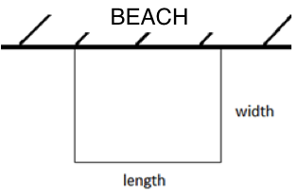
Area | Length | Width | Fence Used
EX4 Beach follow up questions…
Optimal Dimensions and Min Fence Used:
For this particular fence configuration, what is the ratio of length to width that gives the minimum amount of fence?
A 100 foot rope costs $40. The maximum number of swimmers for this 3000m² swimming area is 200.

- What is the least amount of money that could be spent on the rope for the swimming area? (Use your optimal shape from the front of the page)
- A new regulation states that swimming areas should go no further than 25 m away from the beach. How much more money will the campground need to spend on rope?
- A different campground spends $336 on rope, and builds a rectangular swimming area. What is the maximum number of swimmers it will be able to accommodate? (assume it is allowed the same number of swimmers per square meter as the original).
- Let’s say the beach didn’t have to make its swimming area a rectangle. Can you find another way to rope off a 3000 m² swimming area that uses even less rope? Show your work.

