Measurement – Problem Solving
Answers
1. a) 236.2 cm³ b) 493.6 cm²
2. b) 13.6 m³ c) 31.4 m²
d) 680 tanks
3. a) 19 pieces b) 0.9 m
4. a) 5.3 m³ b) 22.5 m²
c) $210 d) 14 cans
e) $301.00

- The diameter of a tennis ball is 6.7 cm. Assuming the 3 balls shown in the picture fit tightly in the canister, determine
a) the amount of empty space in the container
b) the surface area of the container
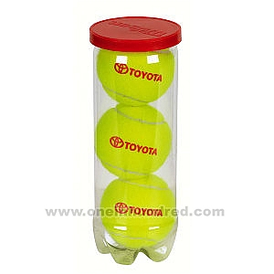
- The tank of a truck is in the shape of a cylinder, with a half sphere on both ends. The entire tank (including the half spheres) is 5.0 m long.
1m³ = 1000L
a) Draw a diagram showing the shapes you will use to calculate the volume (with dimensions)
b) How many m³ of propane can the tank hold?
c) How many square meters of metal is needed to make the tank?
d) If a BBQ tank holds 20 L of propane, how many BBQ tanks can this truck fill?
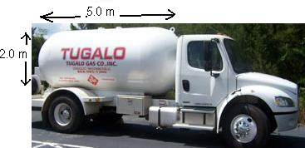

- a) A child’s playhouse is made up of a square-based prism with a pyramid-shaped roof. Assuming there is a floor but no other interior walls or ceilings, how many pieces of cardboard (each measuring 1.4m x 1.4m) are required to make the house?
b) Suppose you have a maximum of 34 square meters of cardboard to work with. You wish to keep the floor area and height of the walls the same as the diagram, but you are willing to alter the height of the roof pyramid. What is the maximum height of the roof pyramid that you can construct out of your available cardboard?
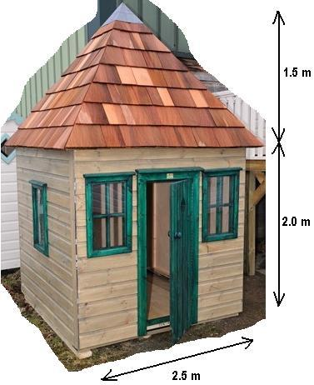
- A frustum is a pyramid that has had its top chopped off; the large concrete frustum in the diagram is now half of its original height (ie. the original pyramid had a height of 2m). As the manufacturer of the frustum you need to determine
a) the volume of concrete required
b) the total surface area of the frustum (including the underside)
c) the total cost if concrete costs $40/m³
d) how many cans of paint you need if one can of paint covers 5 m² and you wish to apply 3 coats of paint
e) the total cost of all the materials (paint and concrete) for this project if a can of paint costs $6.50.
