Measurement – Problem Solving
NOTE:
1L = 0.001 m³
1m³ = 1000L
1L = 1000 mL = 1000 cm³

- The diameter of a tennis ball is 6.7 cm. Assuming the 3 balls shown in the picture fit tightly in the canister, determine
a) the amount of empty space in the container
b) the surface area of the cylindrical container
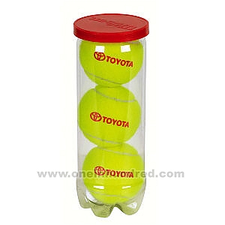
- A water tank in the diagram is a prism with a base area of 800 cm² and a height of 65 cm. If water flows from a hose at a rate of 12 L/min, how long will it take to fill the tank?
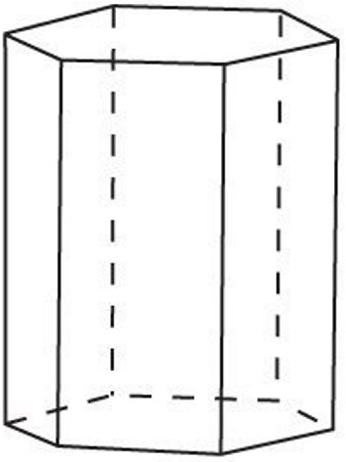
- The tank of a propane truck is in the shape of a cylinder, capped on each end by two semi-spherical ends as shown in the diagram.
a) Draw a diagram showing the shapes you will use to calculate the volume (include dimensions)
b) How many m³ of propane can the tank hold?
c) How many square meters of sheet metal is needed to make the tank?
d) If a BBQ tank holds 20 L of propane, how many BBQ tanks can this truck fill?
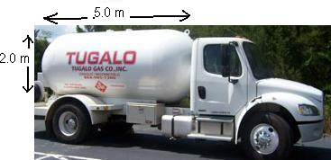

- a) You have a small sphere (r = 5.0cm) and a big sphere (r = 10.0cm). How many times bigger is the volume of the big sphere? Are you surprised?
b) You have two cones with equal bases. One cone has a height of 6.0 cm, the other has a height of 12.0 cm. How many times bigger is the volume of the tall cone?
c) You have two cones with equal heights. One has a base with radius 10.0 cm, the other has a base with radius 20.0 cm. How many times bigger is the volume of the cone with the larger base?
d) Use the formulas for the volume of spheres and cones to explain your answers from a), b) and c).

- a) Find the approximate volume of ice cream in the ice cream cone. Assume (for now) that cone has negligible thickness.
b) If the cone wall has a thickness of 0.2 cm, approximately how much ice cream is in the ice cream cone? (assume the height of the cone stays the same)
c) If the cone wall has a thickness of 0.2 cm, approximately what is the volume of batter needed to make the cone itself? (Assume the cone does not overlap)
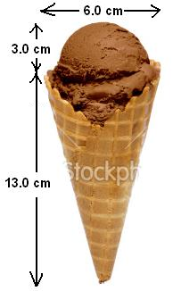

- a) A child’s playhouse is made up of a square-based prism with a pyramid-shaped roof. Assuming there is a floor but no other interior walls or ceilings, how many pieces of cardboard (each measuring 1.4m x 1.4m) are required to make the house?
b) Suppose you have a maximum of 34 square meters of cardboard to work with. You wish to keep the floor area and height of the walls the same as the diagram, but you are willing to alter the height of the roof pyramid. What is the maximum height of the roof pyramid that you can construct out of your available cardboard?
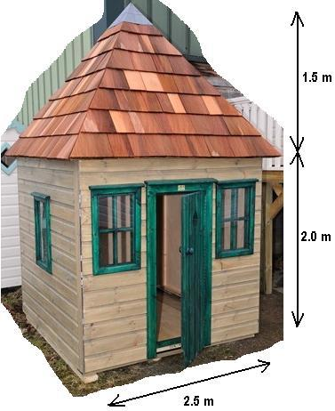

- A frustum is a pyramid that has had its top chopped off; the large concrete frustum in the diagram is now half of its original height (ie. the original pyramid had a height of 2m). As the manufacturer of the frustum you need to determine
a) the volume of concrete required
b) the total surface area of the frustum (including the underside)
c) the total cost if concrete costs $40/m³
d) how many cans of paint you need if one can of paint covers 5 m² and you wish to apply 3 coats of paint
e) the total cost of all the materials (paint and concrete) for this project if a can of paint costs $6.50.
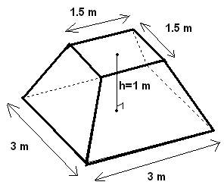

- Alveoli are located in human lungs. They resemble in some ways broccoli, with many small spheres forming bunches. These small spheres are responsible for absorbing oxygen from the atmosphere. The bigger the total surface area of all these spheres, the easier it is for the lungs to absorb oxygen into the blood supply.
When you smoke the walls of the alveoli are broken down, and many small spherical alveoli become one bigger spherical alveoli.
The radius of one alveolus (singular of alveoli) is approximately 0.03 cm. If 10 alveoli of a smoker merge into one single larger alveoli, how many times less surface area does the smoker have for inhalation? The total volume of the small alveoli before smoking remains the same as the big alveoli after smoking, but the surface area changes.
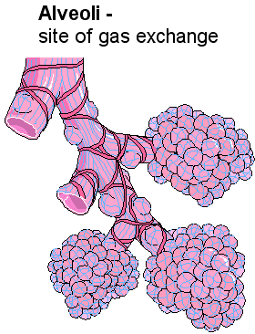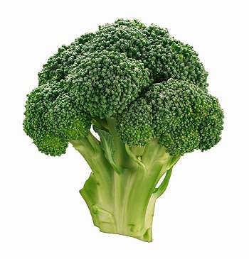
Answers
1. a) 236.2 cm³ b) 493.6 cm² 2. 4.3 mins or 4 m 20s
3. b) 13.6 m³ c) 31.4 m² d) 680 tanks
4. a) 8 times b) 2 times c) 4 times
5. a) 179.1 cm³ b) 148.6 cm³ c) 30.5 cm³
6. a) 19 pieces b) 0.9 m
7. a) 5.3 m³ b) 22.5 m² c) $210 d) 14 cans e) $301.00
8.

