MPM1D – Calculating Volume and Surface Area Name: _________
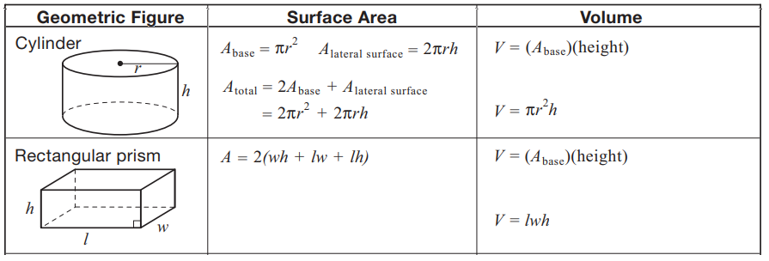
Calculate the surface area and volume of the following shapes. Show your work.
a) b)
