MPM1D – Playdoh-Water-Paper Problems Name: __________________________
In each case:
a) draw a diagram of any relevant shapes/objects, and label any relevant dimensions
b) Solve the problem using (if possible) a formal, algebraic method.
c) For each major step, write a short sentence to explain what is being calculated

- You have a piece of playdoh in the shape of a cylinder with radius 3 cm and height 5 cm.
a) If you double the height of the cylinder, how many times bigger is the new volume?
b) If you double the radius of the cylinder, how many times bigger is the new volume?
- A playdoh cube has side lengths of 7 cm. If you double the length of each side, how many times bigger is the volume?
- If you have 1800 cm² of paper, what are the dimensions of the cube that you could build? (hint: this is the surface area of the cube!)
- You have 200 cm³ of playdoh
a) If you build a cylinder with a radius of 5 cm, what will the height of the cylinder be?
b) If you build a cylinder with a height of 12 cm, what will the radius of the cylinder be?
c) If you form it into a cube, what will the side lengths be? (hint: cube root is involved)
- You have 1000 mL of water
a) If you pour the water into a cylinder with r = 4 cm, to what height will the water rise?
b) If you pour the water into cylinder and the water height is 12 cm, what is the radius of the cylinder?
- A container of water in the shape of a cube has side lengths 12 cm. It is poured into an empty cylinder with a radius of 6 cm. How high will the water level rise?
- You have a piece of playdoh in the shape of a cylinder with radius 4 cm and height 6 cm. If you double the volume of the cylinder and keep the height the same, what will the new radius be?
- A cylinder with a radius of 6 cm has water up to a height of 10 cm. A ball with a radius of 4 cm is placed in. What will the new height of the water in the cylinder be?
- A single piece of paper is big enough to build a cube that has side lengths
10 cm x 10 cm x 10 cm. How many pieces of paper you would need to build a cube that has side lengths that are half as long?
- A container in the shape of a square-based prism with base dimensions 8 cm x 8 cm has walls that are 20 cm tall. Water is poured in to a height of 12 cm. How many golf balls (circumference = 13.4 cm) will it take to make the water level rise by 5 cm?
- First you build a cube using a square piece of paper that has an area of 1800 cm². Then you use a square piece of paper whose length and width are both 25% bigger than the first one. How many times bigger is the volume of the second cube, compared to the first?
- A playdoh sphere has a surface area of 1000 cm². How many small spheres with a radius of 2 cm could this playdoh make?
- You have a ball of playdoh that has a diameter of 8 cm. If the volume of the ball is doubled, by what percent will the diameter increase?
- A ball is dropped into a cylinder of water with a diameter of 10 cm, and it makes the water level rise by 1.5 cm. If you then drop a ball with half the diameter of the first ball into the water, how much will the water level rise?
- You have a sphere of playdoh with a surface area of 500 cm². You form it into a cylinder with
r = 4 cm. Then you break it in half and form two new cylinders with r = 4. How many times smaller is the height of the two smaller cylinders compared to the height of the bigger cylinder?
- A container in the shape of a cylinder has a radius of 6 cm. 8 golf balls are placed in it (circumference = 13.4 cm). If you pour 600 mL of water into the container, what will the height of the water level be (in cm)?
- You have a bunch of small playdoh spheres, each with a diameter of 1cm. How many of these small playdoh spheres will it take to form a large playdoh sphere with a diameter of 10 cm?
- A cylinder with a radius of 6 cm has water up to a height of 10 cm. Three balls are dropped in, and the height of the water rises to 12 cm. What was the radius of each ball?
- You have a hunk of playdoh. You form it into a cube, and measure the side lengths to be 5 cm. You then break the cube into two equal pieces and form new cubes. By what percent has the side length decreased?
- 2000 mL of water and 10 golf balls (c = 13.4 cm) are poured into a container with a square base. The water rises to a height of 15 cm. What are the base dimensions of the container?
- A single piece of paper is big enough to build a cube that has side lengths
10 cm x 10 cm x 10 cm. If you use two pieces of paper instead of one, by what percent could you increase the side length? What about the volume?
- A piece of paper with an area of 1500 cm² is used to build a cylinder whose diameter and height are equal. What are the diameter, height and volume of the cylinder?
- A piece of paper with an area of 1000 cm² is used to build a cylinder whose diameter and height are equal. If the length and width of the piece of paper were both 50% bigger, how many times bigger would the volume of the cylinder be (assume diameter and height remain equal to each other)?
- Student #1 says: “When I double the radius of a cylinder, the volume is 6 times as big.”
Student #2 says: “When I double the radius of a cylinder, the volume is 4 times as big”
Is this possible? Use formulas, examples or explanations to demonstrate why/why not.
- Student #1 says: “When I double the radius of a cylinder, the surface area is twice as big.”
Student #2 says: “When I double the radius of a cylinder, the surface area is three times as big”
Is this possible? Use formulas, examples or explanations to demonstrate why/why not.

ANSWERS (I think!)
1. a) 2 times b) 4 times | 2. 8 times | 3. 17.3 cm | 4a. 2.5 cm
4b. 2.3 cm | 4c. 5.8 cm | 5a. 19.9 cm | 5b. 5.2 cm
6. 15.3 cm | 7. 5.7 cm | 8. 10 + 2.4 = 12.4 cm | 9. quarter piece
10. 7.9 8 golf balls | 11. 1.95 x bigger  (side lengths 17.3 vs 21.7) | 12. 88.7 88 small spheres
13. 26 % growth  (d1 = 8, d2 = 10.08) | 14. (trickier question)  0.1875 cm increase | 15. 2 times smaller (half as big
16. h = 8.2 cm | 17. about 1000 small spheres | 18. r = 2.6 cm
19. 20.6 % decrease | 20. 12.7 cm x 12.7 cm | 21. side length 41%  volume 183 %
22. d = h = 17.8 cm  V = 4460.3 cm³ | 23. 3.4 x bigger

- SUPPLEMENTAL CHALLENGE PROBLEMS
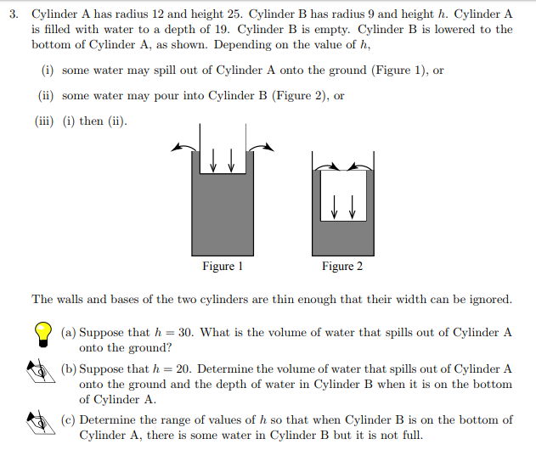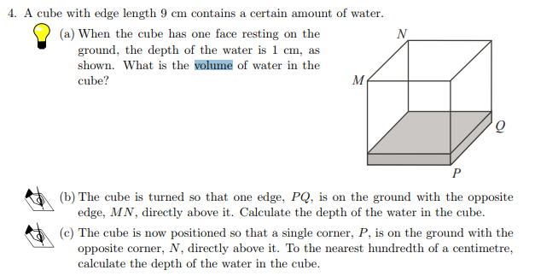

- Alveoli are located in human lungs. They resemble in some ways broccoli, with many small spheres forming bunches. These small spheres are responsible for absorbing oxygen from the atmosphere. The bigger the total surface area of all these spheres, the easier it is for the lungs to absorb oxygen into the blood supply.
When you smoke the walls of the alveoli are broken down, and many small spherical alveoli become one bigger spherical alveoli.
The radius of one alveolus (singular of alveoli) is approximately 0.03 cm. If 10 alveoli of a smoker merge into one single larger alveoli, how many times less surface area does the smoker have for inhalation? The total volume of the small alveoli before smoking remains the same as the big alveoli after smoking, but the surface area changes.
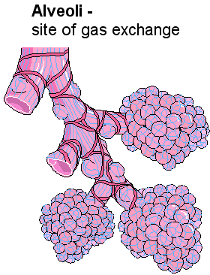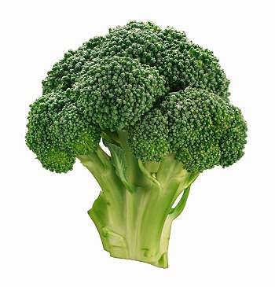

MORE IDEAS
You place a cylinder upright into a wider cylinder with water. Water won’t reach top of second cylinder. How high will it rise?

