MPM1D – Pyramids Practice
$$V=\frac{b^{2}h}{3} \\ SA=b^{2}+4\frac{bs}{2}$$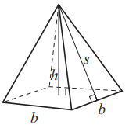
- Calculate the surface area and volume of the pyramid.
Use the formulas to the right. Show your work.
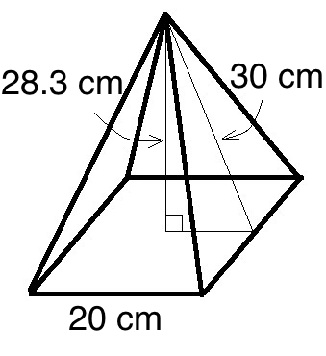
- a) Use the base and height of the pyramid to find the slant height. Show your work.
b) Calculate the surface area of the pyramid. Show your work.
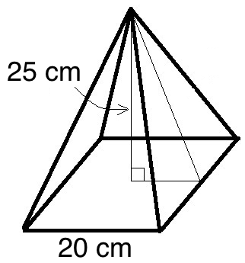
- a) Use the slant height and base to find the height of the square-based pyramid. Show your work
b) Calculate volume of the pyramid. Show your work.
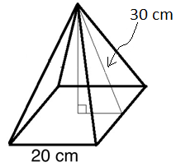
- CHALLENGE QUESTION… A square-based pyramid has a volume of 2000 cm³, and the length of its base is 20 cm. What is the surface area of this pyramid?
