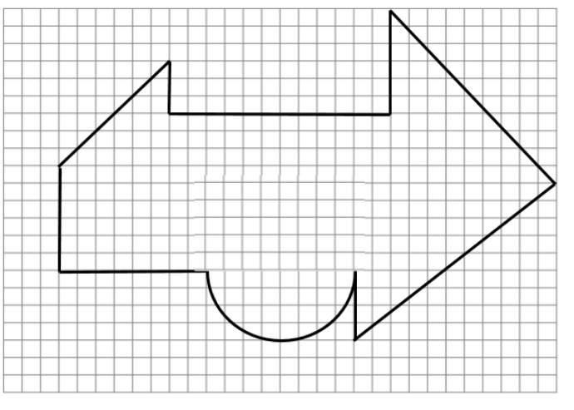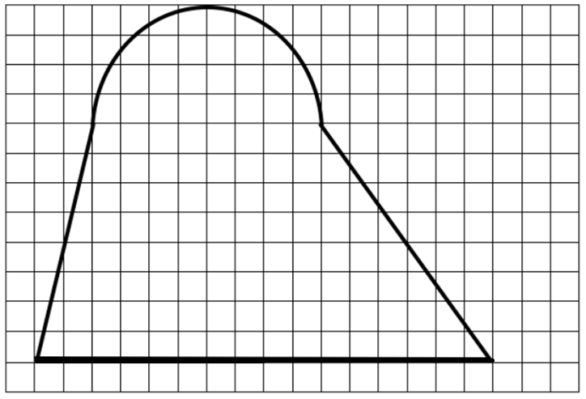
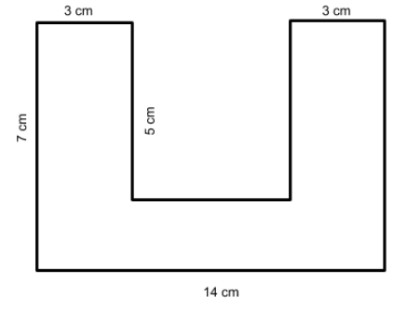

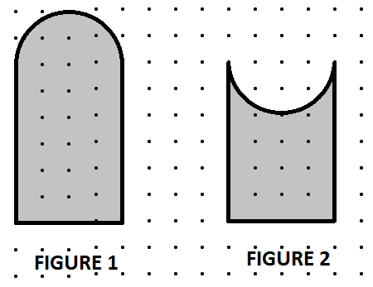
ANSWERS
#2 A = 121.1 cm2 P = 46.8 cm

#3 A = 58 cm2 p = 52 cm

Test question (use shapes similar to #4): Which of these has a bigger perimeter? Explain your answer.

