MPM 1D – Solving for a missing dimension
The area of each shape is given. Determine the value of the variable to one decimal place. Diagrams not to scale.
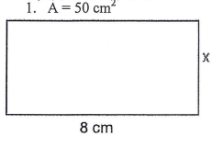 | 2.  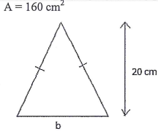
3.  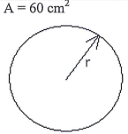 | 4.  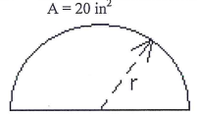
5.  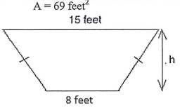 | 6.  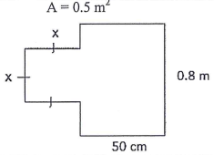
7.  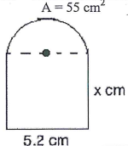 | 8.  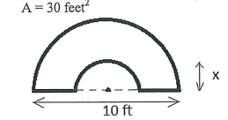
9.  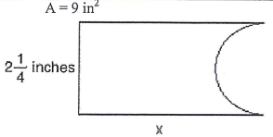 | 10.  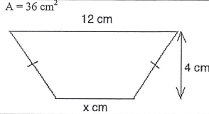
ANSWERS 1. X = 6.3 cm 2. B = 16 cm 3. R = 4.4 cm 4. R = 3.6 in 5. H = 6.0 feet 6. X = 0.3 m
7. X = 8.5 cm 8. X = 2.4 feet 9. X = 4.9 in 10. X = 6.0 cm

