- Find the value of x, and then find the biggest angle. Show your work.  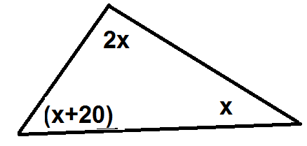 | - Find the value of the smallest angle. Show your work.  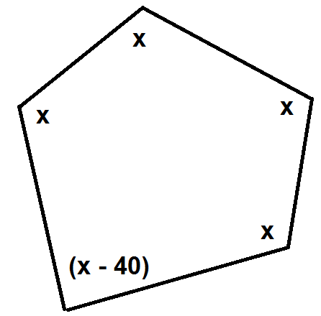
- Find the values of x and y. Show your work. | - Find the value of x. Show your work.

- Find the value of x, and then find the biggest angle. Show your work. | - Find the value of the smallest angle. Show your work.
- Find the values of x and y. Show your work. | - Find the value of x. Show your work.

