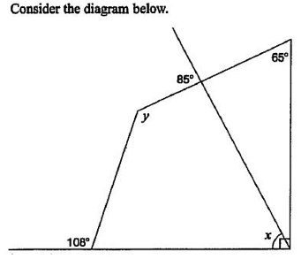  Determine the values of x and y. Justify your answer using geometric properties | x = ___________________ y = ___________________  Justification
Determine the values of x and y. Justify your answer using geometric properties  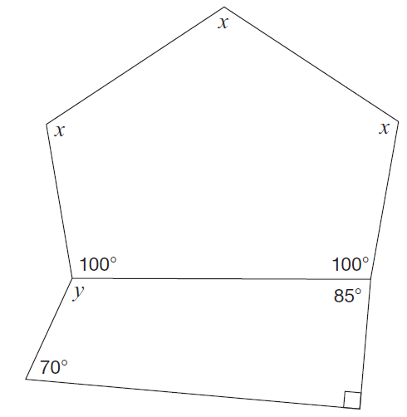 | x = ___________________ y = ___________________  Justification

Another good question

