MCj02506650000[1]For the shapes below, draw markings to show which sides are parallel or have equal length.

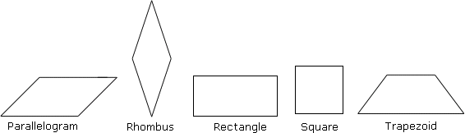

Parallelogram Rhombus Rectangle Square Trapezoid

**Investigation 1:**

1. Draw a quadrilateral ABCD (try to draw one that is ***NOT***one of the special shapes above). Measure the four sides and mark the midpoints. Make E the midpoint of AB, F the midpoint of BC, and so on.

1. Draw line segments joining E to F, F to G, G to H, and H to E. What ***type of quadrilateral*** does EFGH appear to be?
2. Measure and compare the line segments in the smaller quadrilateral. What relationships are there among the lengths of these line segments?
3. Measure the interior angles of quadrilateral EFGH with a protractor. (Write angles on the diagram).
4. Are any of the sides of quadrilateral EFGH parallel? How do you know by looking at the angles?
5. Check with a classmate to see if they got the same result with their quadrilateral.

When you join the midpoints of the sides of any quadrilateral, what shape do you get?

**Investigation 2:**

1. Draw a parallelogram below using a ruler and protractor. Label it ABCD.
2. Draw in the diagonals of the parallelogram and label the point where they cross with an E.
3. Measure the lengths of AE, BE, CE, and DE.
4. What do you notice about how the diagonals cross each other?

What do the diagonals of a parallelogram do to eachother?