Supplemental Problems - Solving Equations With Perimeter and Area
The TOTAL area of the shapes is given. Find the value of x in each case.
- 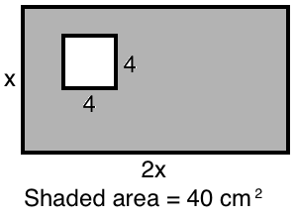 | - 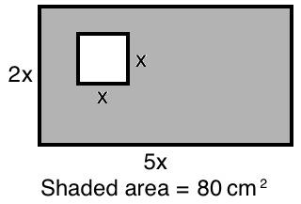

ANSWERS
- X = 4.5 | - X = 3.9 | - X = 7.6 | - X = 20.4
- X = 5.3 | - X = 3.0 | - X = 5 | - X = 13.2

