Distance-Time Graphs – Practice Name: _______________________________

- Mr John will describe the motion of a student. You draw a graph that matches.
a)  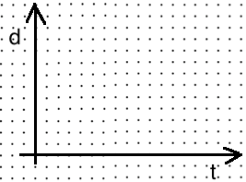 | b)
c) | d)
e) | f)
g) | h)
2. Given a graph, describe the motion of the student. Use words like:
Moving towards, away from, quickly, slowly, stopped, slowing down, speeding up
a)
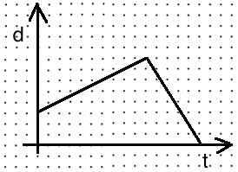
b)
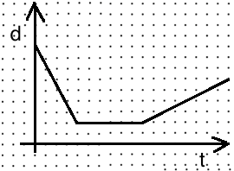
c)
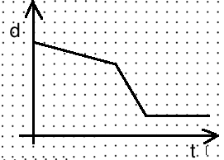
d)
