Scatterplots, Lines of Good Fit, Predictions, Rates of Change Name: ___________________
USE YOUR LINE OF BEST FIT TO MAKE PREDICTIONS.
 | 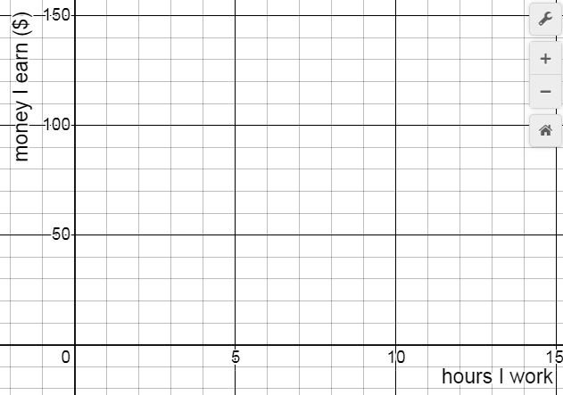
- Make a scatterplot using the data from the table of value. |  | - Draw a line of best fit for the points in your scatterplot.
- How much money will you earn if you work for 7 hours? State the coordinates and mark a point on the graph. |  | - If you earned $90, how long did you work for? State the coordinates and mark a point on the graph.
- Use a point on your line to determine the rate of change. Show your calculation and include units. |  | - Explain the meaning of the rate of change.
- How much money will you earn in one year if you work for 3 hours every day?
 | 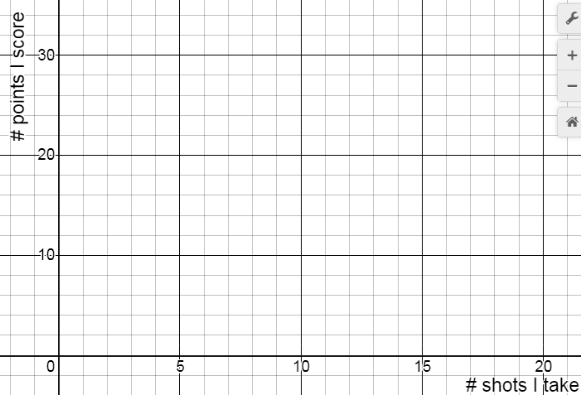
- Make a scatterplot using the data from the table of value. |  | - Draw a line of best fit for the points in your scatterplot.
- How many points will you score if you take 7 shots? State the coordinates and mark a point on the graph. |  | - Predict how many shots you took if you scored 26 points. State the coordinates and mark a point on the graph.
- Use a point on your line to determine the rate of change. Show your calculation and include units. |  | - Explain the meaning of the rate of change.
- You took 24 shots and scored 40 points. Is this more or fewer points than you would expect to score? Explain how you know.

