Analyzing Distance Time Graphs
EXAMPLE (an actual EQAO question from past exam)
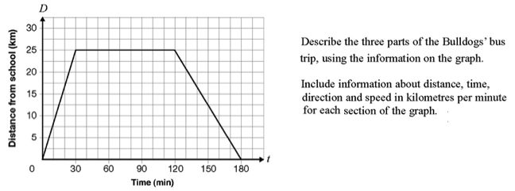
Q1 Misha goes to the store to buy milk. A distance-time graph for Misha can be seen to the right.  1.a) At what letter does Misha leave home?  b) At what letter does Misha arrive at the store?  c) At what letter does Misha arrive at home?  2. How long did it take Misha to get to the store?  3. How long did Misha stay at the store?  4. How long did it take Misha to get home from the store?  6. How far did Misha travel from B to C?  7. How long did it take Misha to travel from B to C?  8. What was Misha’s speed (in m/min) from B to C?  9. Calculate Misha’s speed from E to F.  10. How can you tell (without calculations) that Misha was travelling faster during BC than EF?  12. When is Misha travelling the fastest?  12. When is Misha travelling the slowest?  13. What is the total distance that Misha travels? | 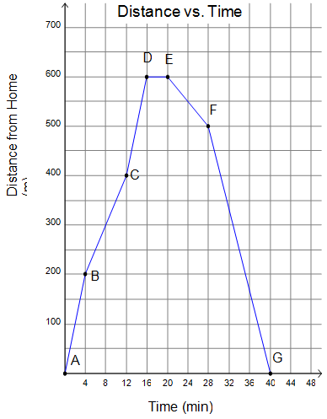

Q2: A Walker’s Walk
Chris walks each day. The graph shows his distance from home.

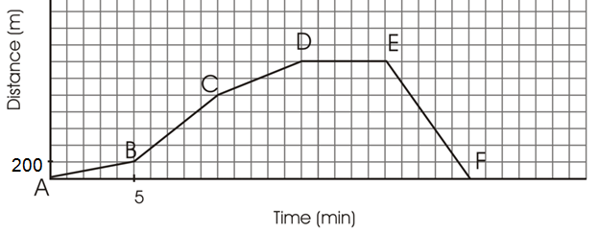
Using the graph, give an explanation of what is occurring over Chris’ walk.
Include information about time, distance, direction and speed during each segment
Q3: Sketching Graphs
Draw a distance-time graph that matches the description.
a) Start 5 m away from CBR. Walk 3 meters further away in 2 seconds. Stop for 3 seconds. Then walk towards CBR at 2 m/s for 3 seconds. Then stop. | b) Start 2 m from CBR. Walk away from CBR at 1.5 m/s for 4 seconds. Stop for 2 seconds. Walk 2 m towards CBR in 2 seconds, then speed up and walk towards CBR at 2 m/s for 3 seconds.
Q4: More Drawing Graphs:
Draw a distance-time graph to match the following story:
Terri played soccer 4 km from her home. She gets on her bike and starts to ride home. After 10 minutes she is 2 km from her home but she is also tired and rests for 5 minutes. She then rides towards home at 0.1 km/min for 10 minutes. After that she rides the remaining distance in 5 minutes, going faster and faster until she reaches her home.

Q4. More sketching practice
Sketch the graph of a journey that includes: a fast walk, a slow walk, some time standing still, moving towards, moving away, and slowing down. Make sure to label each of the components.
ANSWERS (I think!)

Corner Store
- 16 mins
- 4 mins
- 20 mins
- Line going up and to right away
Line going down and to right towards
- 200 m
- 8 mins
- 200/8 = 25 m/min
- 12.5 m/min
- Line BC is steeper: up 4 over 2, vs EF down 2 over 2
- AB – steepest line
- EF
- No – point G is when they get home, it is after 40 minutes

Q2 – Walker’s Walk
 | Distance (m) | Direction | Time (min) | Speed (m/min)
AB | 200 | Away | 5 | 40
BC | 800 | Away | 5 | 160
CD | 400 | Away | 5 | 80
DE | 0 | N/A | 5 | 0
EF | 1400 | towards | 5 | 280

Drawing Graphs
