MPM1D – Multiple Representations Practice
Try to represent each relationship:
-as a table -in words -as an equation -as a graph
1. | 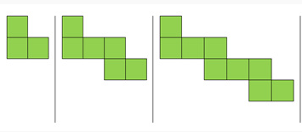
2. | A taxi driver charges a flat fee of $2.50 plus $0.50 per kilometre.
3. | 4, 10, 16, 22, 28, …
4. | T = 7n + 2
5. | input output  1 7  2 5  3 3  4 1
6. | 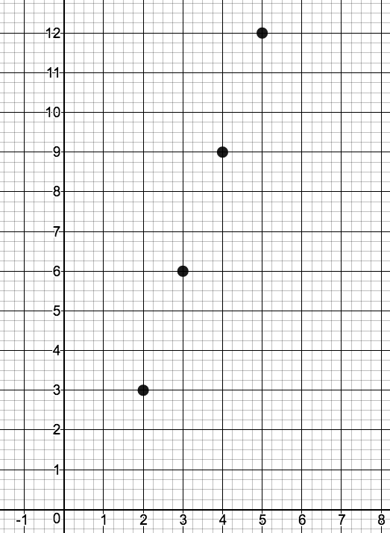
7.

