MPM1D – Multiple Representations Practice
Try to represent each relationship:
-as a table -in words -as an equation -as a graph
1. | 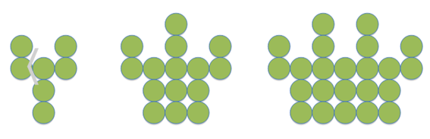  Figure 1 Figure 2 Figure 3
2. | As a babysitter you are paid $10 just for showing up, and an additional $6 for every hour you babysit
3 | Time (minutes) Candies remaining  1 7  2 5  3 3  4 1
4. | T = 2n + 7
5. | 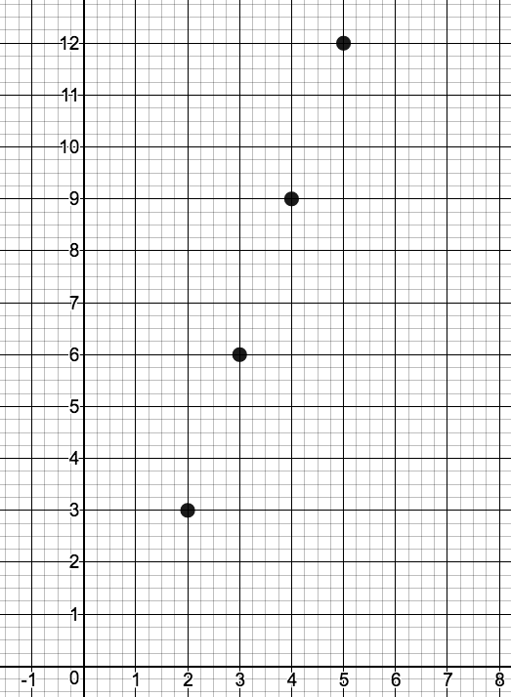
6.

