MPM 1D: Representations Activity
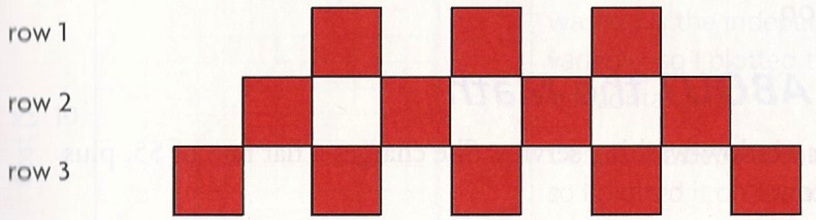
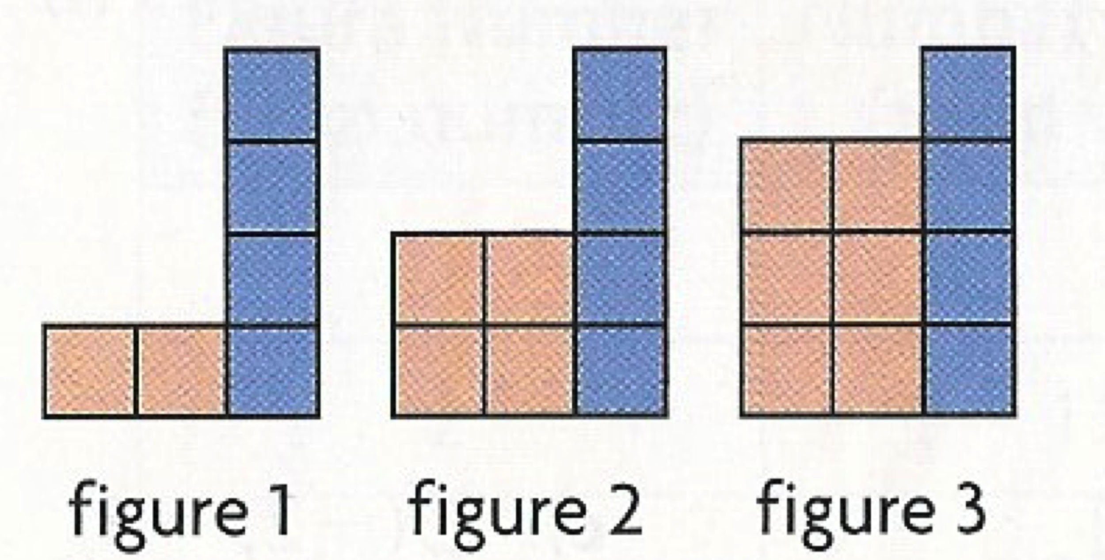
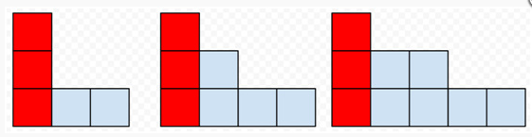
FIGURE 1 FIGURE 2 FIGURE 3

# weeks | Height of plant (cm)
1 | 5
2 | 8
3 | 11
4 | 14

Time(s) | # cubes linked
1 | 3
2 | 5
3 | 7
4 | 9

T = 4n + 3
C = 3p + 1
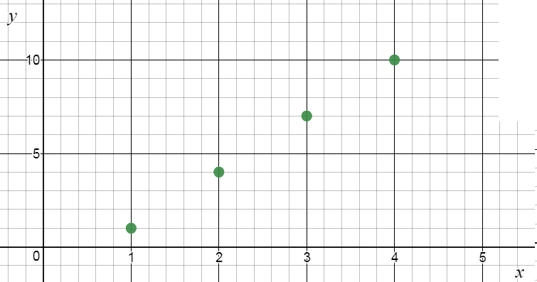

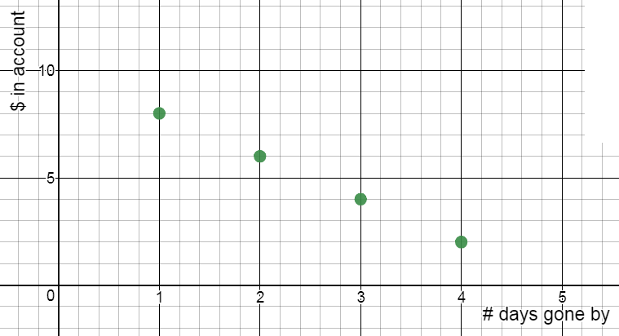

Time(s) | Height of balloon (m)
0 | 10
10 | 12
20 | 14
30 | 16

# visitors | # Timbits left
5 | 50
10 | 40
15 | 30
20 | 20

Add some more challenging tables for gifted class (rows mixed up, hard to find y-int, non-linear, exponential, absolute value, reciprocal, square root…could give as table, graph or words)

