MPM1D – Cube Toss Changes and Representations
In each question below, the cube toss experiment is done twice: Trial A and Trial B. In each case, a change has been made to the situation that will change the data, equation, graph, picture and words. Complete the table. Point form is fine for the explanations.
Representation #1 | Representation #2 (add for Trial B) |  |  | Explanation: why is Trial B like this?
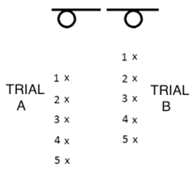 | 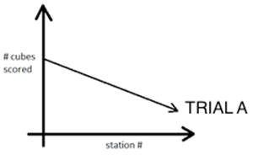
Representation #1 | Representation #2 (add for Trial B) |  |  | Explanation: why is Trial B like this?
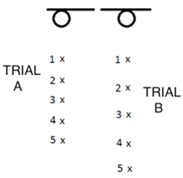
Representation #1 |  | Representation #2 (add for Trial B) |  | Explanation: why is Trial B like this?
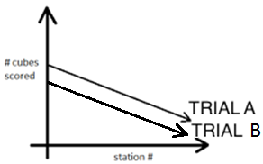 |  | 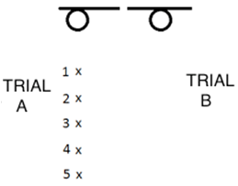
Representation #1 |  |  | Representation #2 (add for Trial B) | Explanation: why is Trial B like this?
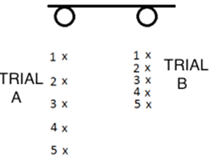 |  |  | TRIAL A:  $$y=-7.5x+80$$TRIAL B:
Representation #1 |  |  | Representation #2 (add for Trial B) | Explanation: why is Trial B like this?
TRIAL A:
$$y=-9x+70$$TRIAL B:
$$y=-9x+50$$

Representation #1 | Representation #2 (add for Trial B) | Explanation: why is Trial B like this?
TRIAL A:
$$y=-6x+70$$TRIAL B:
$$y=-8x+70$$

Representation #1 | Representation #2 (add for Trial B) | Explanation: why is Trial B like this?
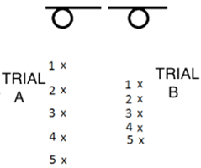 | TRIAL A:  $$y=-8.2x+70$$TRIAL B:

Representation #1 | Representation #2 (add for Trial B) | Explanation: why is Trial B like this?
