MDM1D Cube Toss — Moving back Name: ______________________________________

- Make a scatterplot and draw a line of best fit for the cube toss data shown in the table.
station # | # scored
1 | 90
2 | 77
3 | 65
4 | 49
5 | 39
6 | 24
- Describe the correlation of the data (linear/non-linear, positive/negative, strong/medium/weak)
- How many cubes would the class score from station 7? State the Coordinates And Mark a Point (SCAMP) on the graph.
- Imagine the class threw from halfway between stations 3 and 4. How many cubes do you think it would score from there? SCAMP
- 4. From what station number would the class need to throw from in order to score 30 cubes?
SCAMP
- 5. From what station number would the class need to throw from in order to get zero cubes in the bucket? SCAMP

6. For every station we moved backwards, what happened (approximately) to the number of cubes we scored? Explain how you got your answer.
Cube Toss – Key Features Name: ______________________________________

- A class of students repeats the activity. Its scatterplot and line of best fit are shown in the graph.

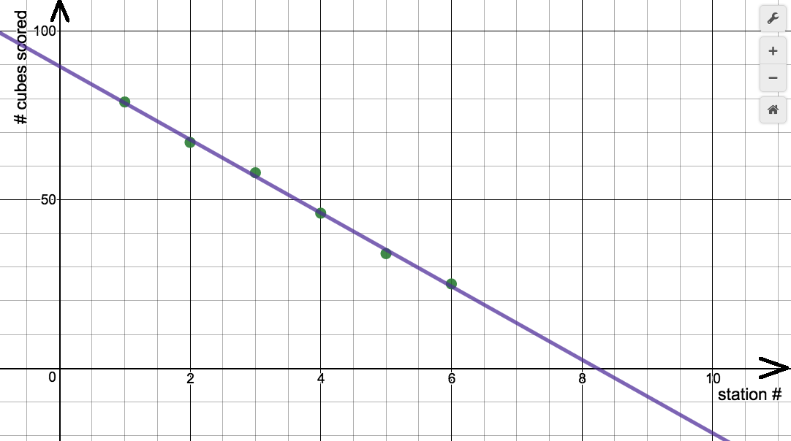
QUESTION | KEY FEATURE
2. About how many cubes would the class score from station 0? SCAMP | We call this the y-intercept. It is where the  _______________________________________ crosses the  _________________________________. At the y-intercept,  value of x is always _______________________________.
3. From what station would we score 0 cubes? SCAMP | We call this the x-intercept. It is where the  _______________________________________ crosses the  _________________________________. At the x-intercept,  value of y is always _______________________________.
4. For every station the class moved backwards, what happened (approximately) to the number of cubes they scored? | We call this the rate of change. Every time the  variable on the x-axis gets ___________________________  by 1, what happens to the variable on the  _____________________________?

- For the following cube toss graphs, determine the key features. SCAMP
a)  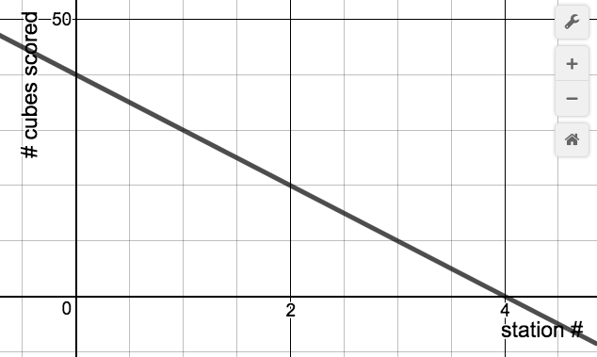 | KEY FEATURES (y-int, x-int, rate of change)
b)
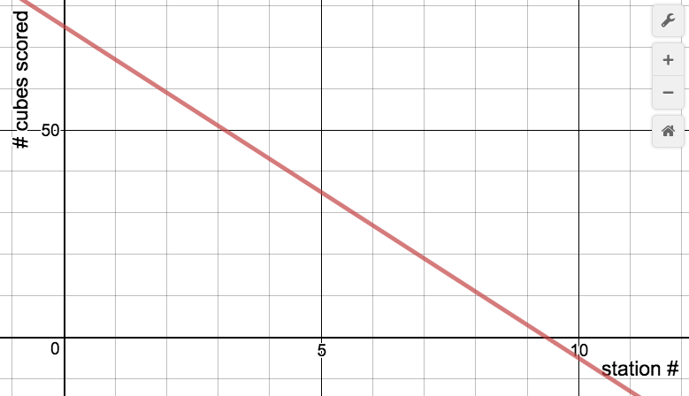
7. a) A class does the cube toss and a point on its line of best fit is (5, 40). What does this point mean?
b) Why does it make sense for the rate of change to be negative in this activity?
c) What is the meaning of the x-intercept in this activity? (use words like cubes, stations, etc.)
d) What is the meaning of the rate of change in this activity?
Cube Toss – Equations and Regressions Name: ___________________________________
Below is the same graph we used on page 2 of this package, together with the table of values that was used to make the scatterplot.
station # | # scored
1 | 79
2 | 68
3 | 58
4 | 46
5 | 34
6 | 25
1. What were the y-intercept, x-intercept and rate of change? You can look back to page 2 or do it again.
y-intercept = | x-intercept = | rate of change =

2. Now make a scatterplot using Desmos, then perform a regression to draw a line of best fit (Mr John will show you how). What is the equation of your line of best fit?
3. Compare your equation from #2 to the key features you identified in question #1. What do you notice?
Write an equation that would work for a class that:
- Scores 50 cubes from station 0, and scores 8 fewer cubes with every station it moves back | - Scores 86 cubes from station 0, and scores 6 fewer cubes with every station it moves back
Given the cube toss equation, describe the relationship between station number and cubes scored
- $y=-7.5x+105$ | - $y=72-6x$
Cube Toss – Regressions Practice Name: ___________________________________
For each of the following tables of values, perform a regression. Record the regression equation, and use the table in the graphing calculator to predict: How many cubes will be scored from station 7? From what station # would the class score 30 cubes?
station # | # scored
1 | 50
2 | 44
3 | 38
4 | 33
5 | 25
- REGRESSION EQUATION:
__________________________________________________________________
# CUBES SCORED FROM STATION 7?
__________________________________________________________________
FROM WHICH STATION WOULD CLASS SCORE 30?
__________________________________________________________________

station # | # scored
1 | 98
2 | 90
3 | 81
4 | 75
5 | 65

- REGRESSION EQUATION:
__________________________________________________________________
# CUBES SCORED FROM STATION 7?
__________________________________________________________________
FROM WHICH STATION WOULD CLASS SCORE 30?
__________________________________________________________________
station # | # scored
1 | 58
2 | 54
3 | 49
4 | 45
5 | 40
- REGRESSION EQUATION:
__________________________________________________________________
# CUBES SCORED FROM STATION 7?
__________________________________________________________________
FROM WHICH STATION WOULD CLASS SCORE 30?
__________________________________________________________________

Cube Toss – Changing Conditions Name: ______________________________________
Imagine we did the cube toss activity twice, except the second time we changed the location of the throwing stations. Surely this will change how many cubes we score, right? Let’s think about this.
In each case, identify how the key features (y-intercept, x-intercept, rate of change) will change between the two different cube toss activities. Then sketch (and label) the two lines of best fit.
THROWING STATION SET UP | 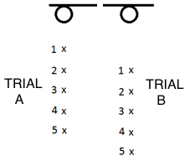 | 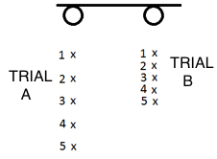
HOW & WHY KEY FEATURES WILL CHANGE (POINT FORM IS FINE) | y-intercept: will be lower in trial B. First station is further away, so we will score less  x-intercept:  rate of change: | y-intercept:  x-intercept:  rate of change:
SKETCH OF GRAPH (ADD LINE FOR TRIAL B) | 