The table below gives information about how much fuel is in the tank of two cars.
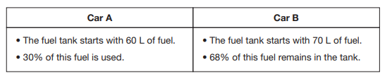
Which car has more gas left in its fuel tank? Show your work.

