Recall: First we need to evaluate things in brackets. Second we evaluate any exponents and roots.
Third we do any multiplication or division. Fourth, we do addition and subtraction.
1. Evaluate. Show your steps.
a) $2(15 – 18)$ b) $7 – 3(4^{2} + 10)$ c) $15-2×3^{2}÷6$
d) $120-4\left[3\left(-2+3\right)+5\right]$ e) $-6+\left(-3\right)-(-4+8)×4÷(-2)$

f) g) h)
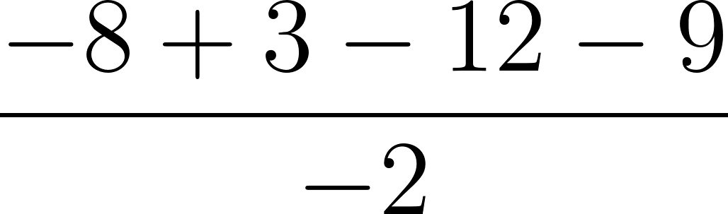 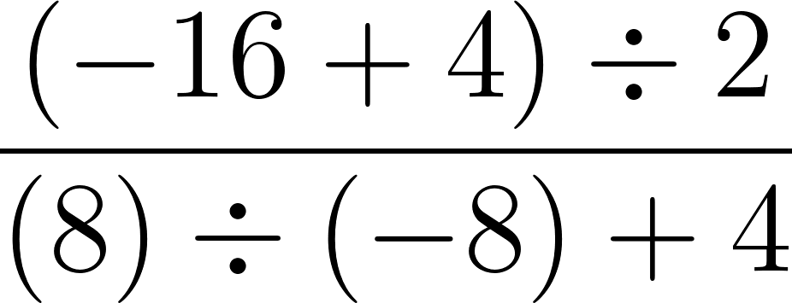 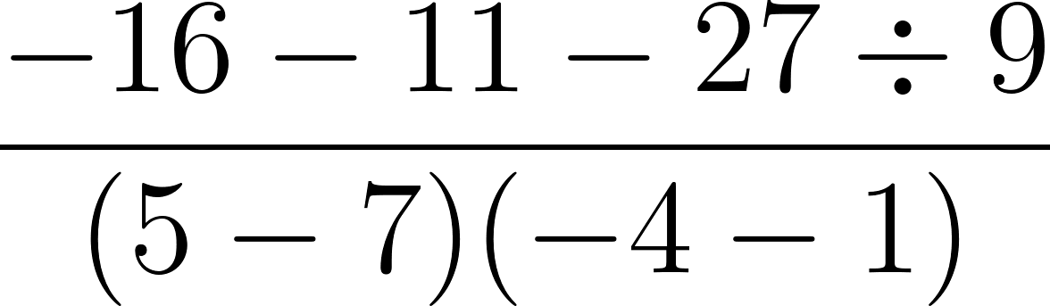

i) $\frac{120÷\left(25-30\right)}{8×\left(-2+3\right)}$ j) ${\left[3(4+1)+{\left(6-2\right)}^{2}\right]}^{2}$
2.
3.
