Recall: First we need to evaluate things in brackets. Second we evaluate any exponents and roots.
Third we do any multiplication or division. Fourth, we do addition and subtraction.
1. Evaluate. Show your steps.
a) $2(15 – 18)$ b) $7 – 3(4^{2} + 10)$ c) $15-2×3^{2}÷6$
d) $120-4\left[3\left(-2+3\right)+5\right]$ e) $-6+\left(-3\right)-(-4+8)×4÷(-2)$

f) g) h)
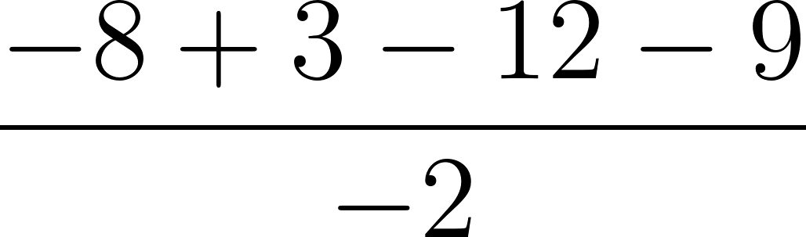 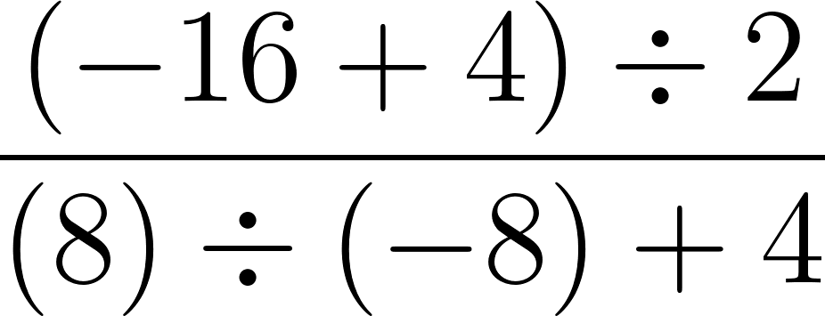 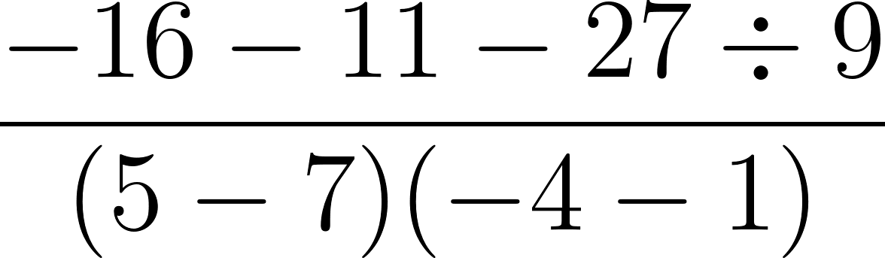

i) $\frac{120÷\left(25-30\right)}{8×\left(-2+3\right)}$ j) ${\left[3(4+1)+{\left(6-2\right)}^{2}\right]}^{2}$

2. a) Place brackets in the expression below to get a result of 31.
$$–12 ÷ (–2) × 8 – 4 × 3 + 5$$

b) Place brackets in the same expression to get a result of 77.
$$–12 ÷ (–2) × 8 – 4 × 3 + 5$$

3. a) Create an expression that would give the same result, if you calculated in order from left to right, as if you used the proper order of operation rules. Include both a division and a subtraction.

b) Explain why the rules did not matter in this case.

- Adam has $450. He spends $210 on food. Later he divides all the money into four parts out of which three parts were distributed and one part he keeps for himself. Then he found $50 on the road. Write a mathematical expression for the amount of money he has, and find his final amount.

- Mel had $35 and withdrew $200 from her bank account. She bought a pair of pants for $34.00, 2 shirts for $16.00 each, and 2 pairs of shoes for $24.00 each. Write a mathematical expression to represent the amount of money she has, and determine her final amount.

