Numeracy – Problem Set 2
IF YOU ENJOY THESE, WRITE WATERLOO MATH CONTESTS! SEE MR JOHN FOR DETAILS
1.  C 2006 #9 | 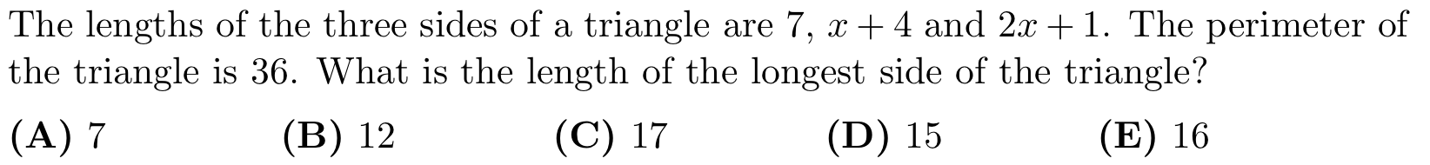
2.  P 2005 #7 | 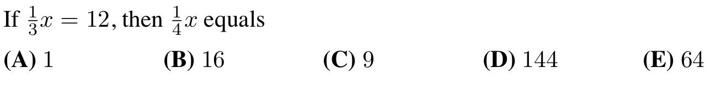
3.  P 2009 #8 | 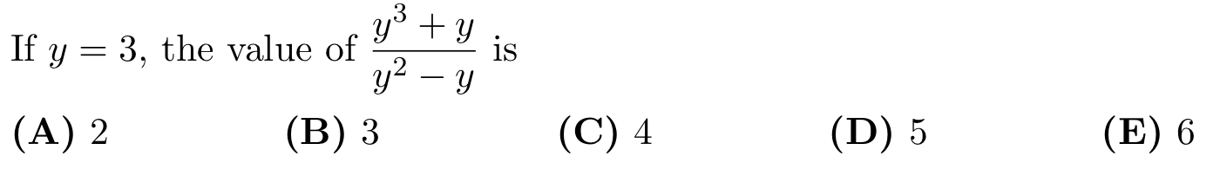
4.  C 2000 #7 | 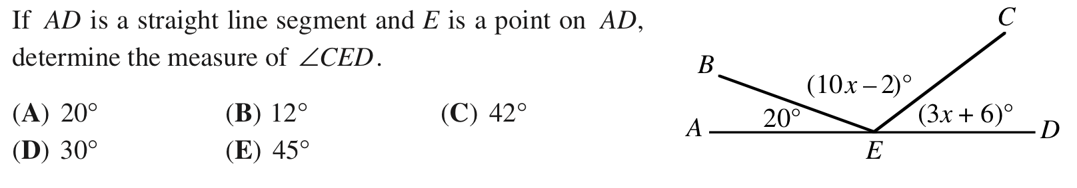
5.  C 2002 #12 | 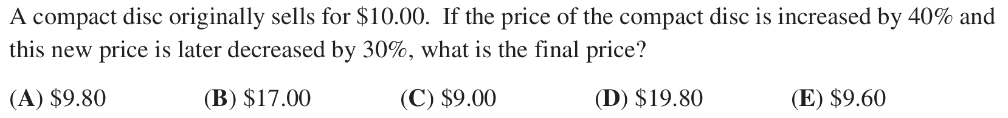
6.  P 2003 #11 | 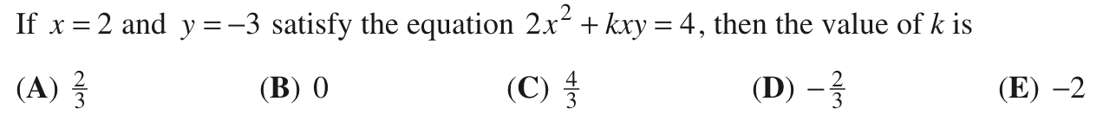
7.  P 2004 #12 | 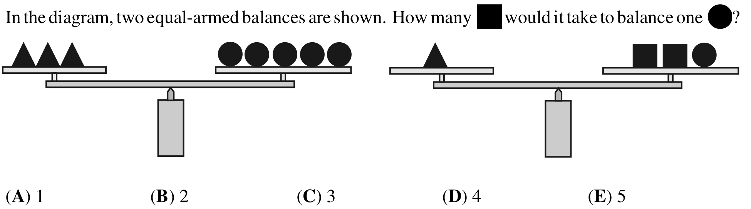
8.  C 2009 #11 | 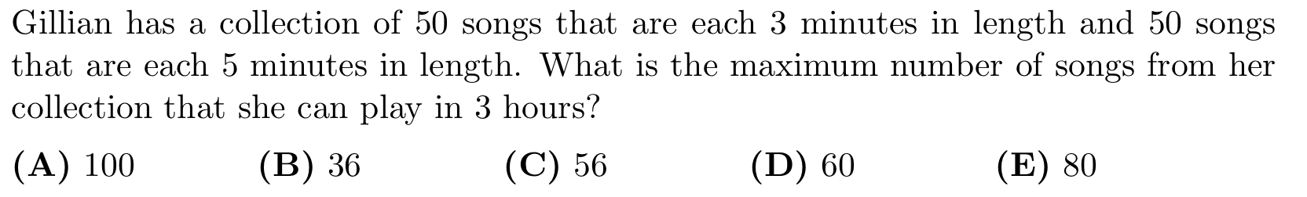
9.  P 2011 #15 | 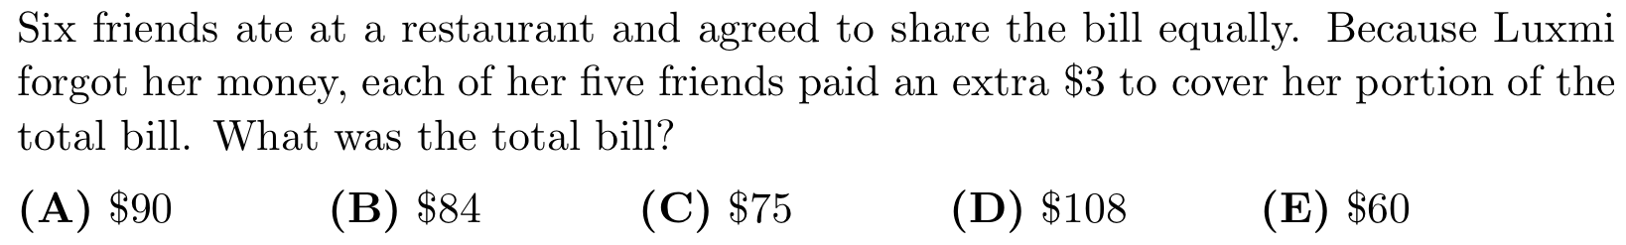
10.  C 1997 #17 | 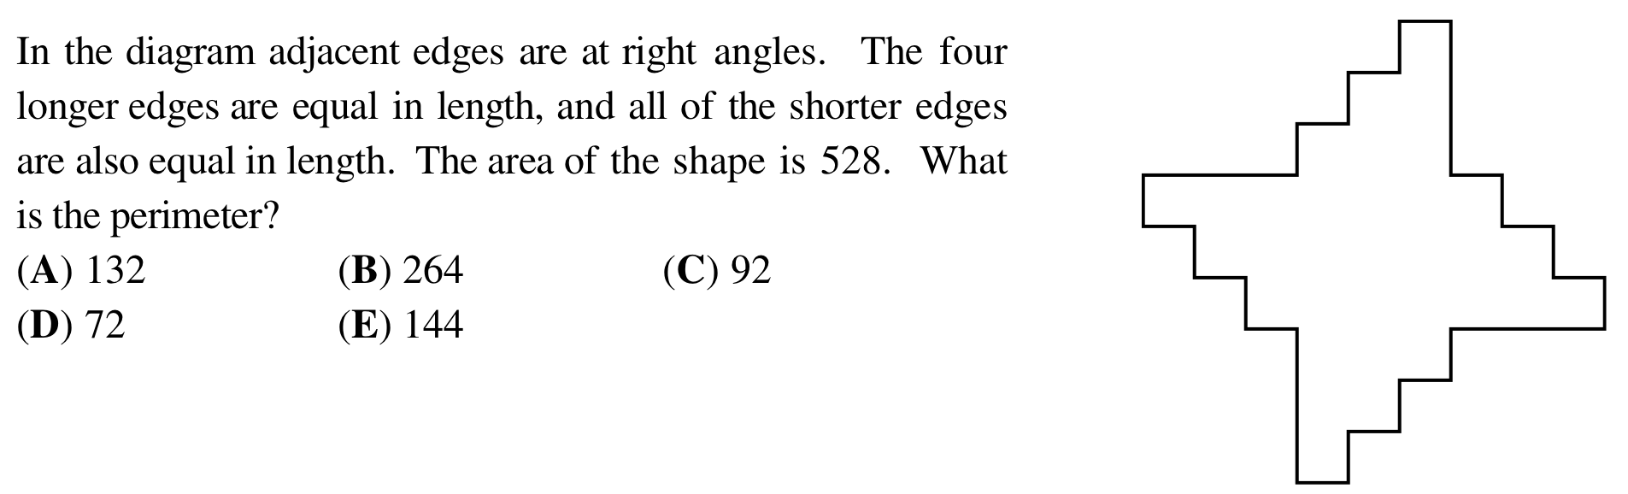
11.  P 2004 #18 | 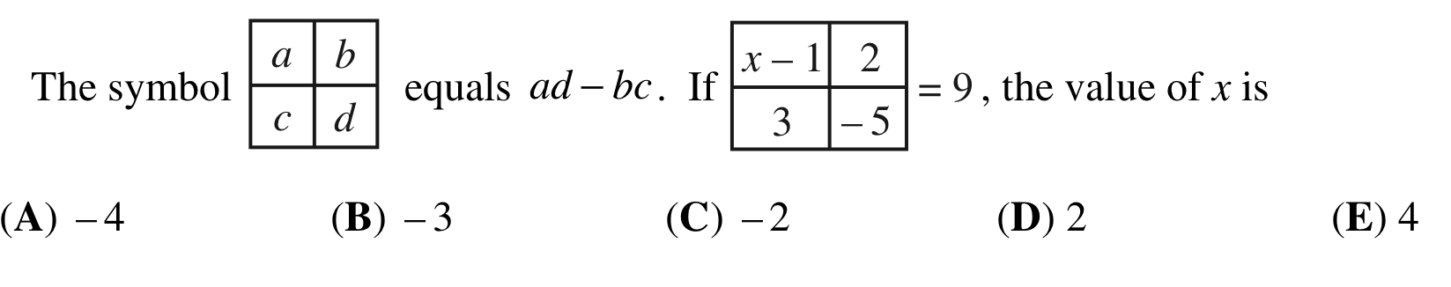
12.
C 2006 #14
13.  P 2010 #18 | 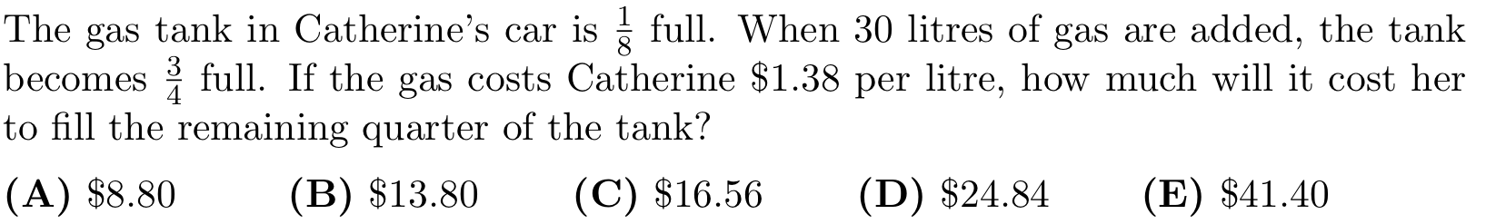
14.  C 2008 #18 | 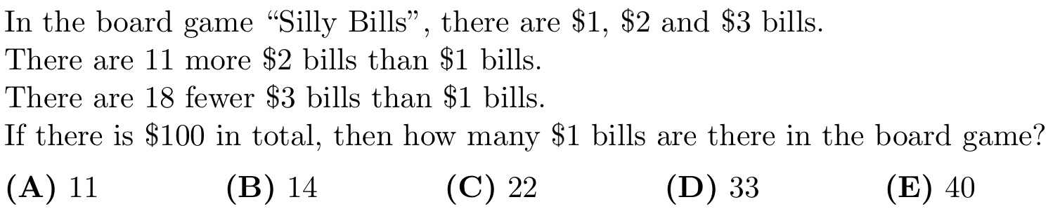
15.  C 2003 #21 | 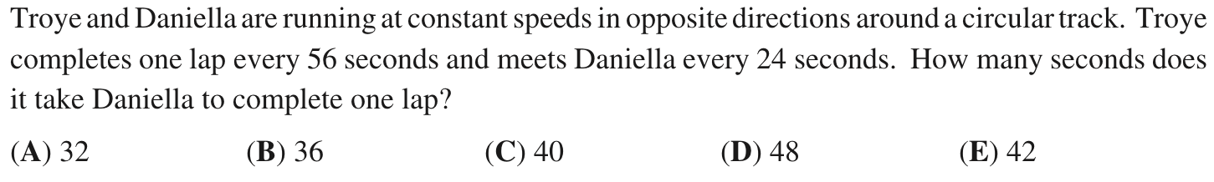
16.  P 2006 #20 | 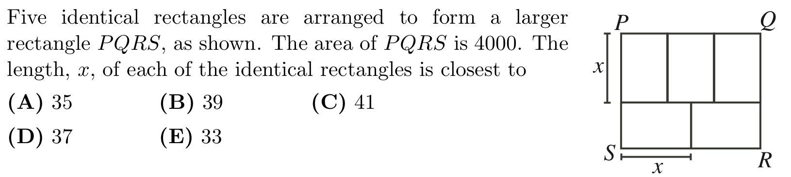
17.  C 2010 #21 | 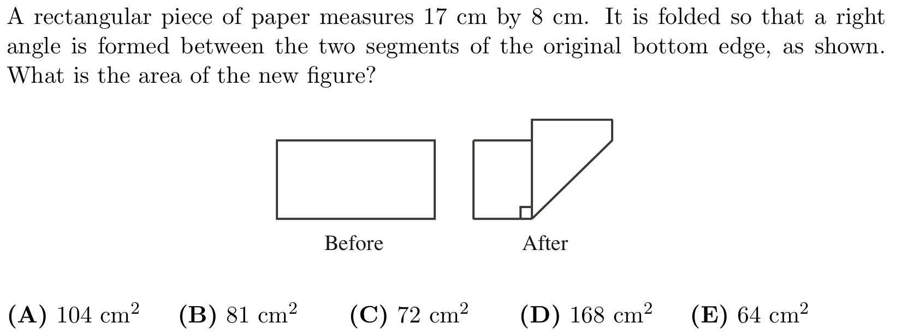
18.  P 2009 #23 | 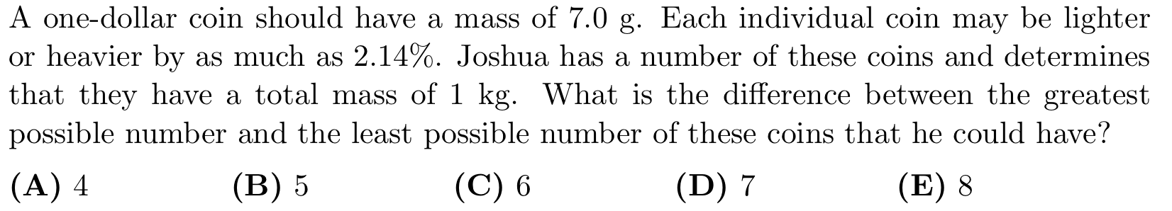
Answers: 1.C 2.C 3.D 4.C 5.A 6.A 7.C 8.C 9.A 10.E 11.C 12.D 13.C 14.C 15.E 16.A 17.A 18.B

