# Energy – An introduction

This link (<https://bit.ly/343Lgsp>) can be useful. We group energy into two broad categories:  
  
potential energy: ______________________________________________________________________________________  
  
kinetic energy: ________________________________________________________________________________________  
  
Within these broad categories there are more specific types of energy…

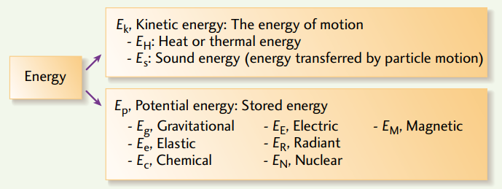  
  
Use the resource linked to above identify one or two examples of each type of energy.

|  |  |
| --- | --- |
| Thermal/heat/sound (K): | Gravitational (P): |
| Elastic (P): | Chemical (P): |
| Electric (P): | Magnetic (P): |
| Radiant (P): | Nuclear (P): |

Using various technologies, we are able to transform energy from one form to another. For example, a hydroelectric damn:

Kinetic energy of water 🡪 electrical energy

For each of the following processes, identify the energy transformations that are taking place. Note that there can be multiple transformations, or multiple types of energy produced.

|  |  |
| --- | --- |
| 1. A match is burning | 1. A gas lawnmower cuts the grass |
| 1. A computer | 1. A hairdryer |
| 1. A battery powered flashlight | 1. A wind turbine |
| 1. A bow and arrow shoots an arrow | 1. A nuclear bomb explodes (far, far away) |
| 1. A wrecking ball demolishes a house | 1. Solar panels power signs on the highway |
| 1. A gas furnace heats your home | 1. Someone jumps on a trampoline |

***Unfortunately, when we transform energy from one form to another the transformation is not perfect. Some of our input energy gets transformed into other unneeded/undesired/unusable forms of energy, and is essentially wasted.***

# Energy in Canada – A snapshot

Where do we get our energy from? Where does it go? How efficient is it? The resource found here provides a good visual of how our energy system works: <https://www.cesarnet.ca/visualization/sankey-diagrams-canadas-energy-systems>

1. ***Start by looking at the energy flow (“All flows”) for all of Canada in the year 2013*** Roughly speaking, how does the amount of energy Canada exports compare to how much it uses domestically?
2. ***Now select “Only Domestic flows” for all of Canada in the year 2013.*** What are the main sources of energy in Canada? Write them in order from greatest to least, and estimate (roughly) what percentage each source produces. Take a minute to reflect on your answer. Does anything surprise/bother/encourage you? (no need to write)
3. Look towards the right of the chart: what main categories is the energy being used for? Rank them roughly from greatest to least. Take a minute to reflect. Is this what you expected? Anything surprising? (no need to write)
4. Summarize what you see when you look all the way to the right of the chart. Any reaction? Where is all the energy going?

1. ***Now compare Canada’s energy flow in 2013 to 1990 (link if desired:*** [***https://bit.ly/3dsrWb0***](https://bit.ly/3dsrWb0)***).*** Any major differences? Similarities?
2. ***Now compare Ontario’s 2013 energy flow to other major provinces (Quebec, BC, Alberta) (link if desired:*** [***https://bit.ly/33ZiFEv***](https://bit.ly/33ZiFEv)***).*** Identify some major differences between the provinces.

The charts are interactive – spend some time clicking the various energy flows for additional learning.

# Tracking Energy

## A: The Pullback Car

Your teacher will demonstrate the motion of ***a pullback car***. We will use the following events:

|  |  |  |  |  |
| --- | --- | --- | --- | --- |
| 1. start pulling car back | 2. finish pulling car back | 3. the instant you release the car | 4. car at max speed | 5. car comes to rest |

1. At which event(s) does the car have primarily potential energy? How do you know?
2. At which event(s) does the car have primarily kinetic energy? How do you know?
3. At which events(s) does the car have neither potential nor kinetic energy? How do you know?
4. What energy transformation is primarily taking place between events 1-2? Explain.
5. What energy transformation is primarily taking place between events 3-4? Explain.
6. What happened to the energy that the car had between events 4 and 5?
7. Complete the energy bar charts for each interval. Events are listed above.

From rest to pullback… From release to max speed… From max speed to rest…  
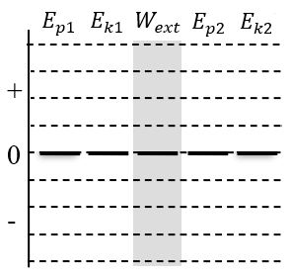 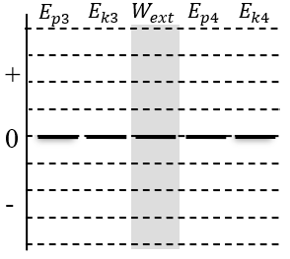 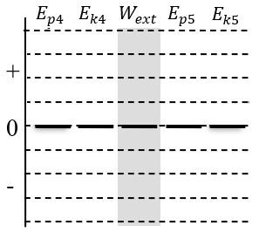

**The Idea of the Conservation of Energy.** Energy cannot be destroyed and energy can’t be created. This powerful idea is called the *conservation of energy*.

**Gravitational Potential Energy** – One specific type of potential energy is gravitational potential energy. When you raise an object up in the air, the object now has more potential energy than when it was lower. A brick held an inch above your foot as compared to a brick held up over your head – which has more potential to do damage? We will often use $E_{G}$ to represent this specific type of potential energy, but in the diagrams below we will continue to use $E_{p}$.

## B: The Pullback Car…on an inclined plane

Your teacher has a car set up at the bottom end of an inclined track. The car has already been pulled back, and we will call the car’s initial height zero. We will use the following events:

|  |  |  |  |  |
| --- | --- | --- | --- | --- |
| 1. car being held, already pulled back | 2. car part way up ramp | 3. car at max height | 4. car part way down ramp | 5. car reaches initial position while moving |

1. At which event(s) does the have:

|  |  |  |  |  |
| --- | --- | --- | --- | --- |
| a) at least some potential energy | b) at least some kinetic energy | c) only potential energy | d) only kinetic energy | e) some kinetic and some potential |

1. What is the difference between the potential energy at event 1 and the potential energy at event 3?
2. Suppose friction did not exist, and all the energy that the car had at event 1 is conserved by the system throughout the process. Draw energy bar diagrams for each interval.

Interval 1-2 Interval 2-3 Interval 3-4 Interval 4-5

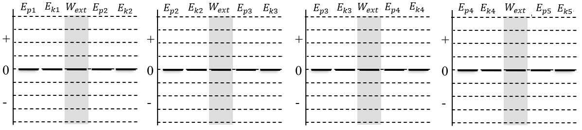

1. Now, let’s consider friction. Suppose the rubbing of the tires on the ramp cause the car to lose a half bar of energy during every interval. Draw energy bar diagrams for this situation.

Interval 1-2 Interval 2-3 Interval 3-4 Interval 4-5



1. How can we tell that the diagrams in #4 are a better representation of the situation than #3?

# Homework: Tracking Energy Name:

**Energy Thinking Process:** To track energy, we must answer two important questions:

1. **Which characteristics of the system are changing?** Start by deciding whether characteristics like the object’s *speed* or vertical position is changing. This helps you decide which energies increase, decrease, or stay the same and draw the bar chart. Double check the bar chart math!
2. **Is energy flowing in or out of the system?** Are there any objects in the environment that are adding energy to or removing energy from the system?

**Represent and Explain.** You are moving a book with your hand. Three different situations are shown below. For each, complete a bar chart. For each situation, describe the characteristics that are changing and any energy flows. Complete the bar chart double-check; after you count the number of block in each section, the equation at the top should make sense.



*y*1

*y*2

*v*2

*v*1

Ek1 + Eg1+Wext = Ek2 +Eg2

+

0

-

•

•

•

•

•

•

•

•

2

1

**Describe changes:**

* The velocity is constant, so Ek stays the same
* The book is going up, so Eg increases

**Energy flow:**

* Energy flows in because of the hand

**Double check**: + =



*y*2

*y*1

*v*1

*v*2

Ek1 + Eg1+Wext = Ek2 +Eg2

+

0

-

•

•

•

•

•

•

1

2

**Describe changes:**

**Energy flows:**

**Double check**: + =

© 2020 C. Meyer



*y*1

*y*2

*v*2

*v*1

Ek1 + Eg1+Wext = Ek2 +Eg2

+

0

-

•

•

•

•

2

1

**Describe changes:**

**Energy flows:**

**Double check**: + =

# Tracking Energy Homework

For each description, complete the energy bar chart and motion diagram, then identify the energy transformations that occur.

|  |  |
| --- | --- |
| 1. A car starts from rest at the top of a hill, and the driver accelerates going down the hill | 1. A parachute glides smoothly to the ground at constant velocity. |
| 1. A race car accelerates quickly along a flat race track | 1. A cannonball is shot upwards and smashes through a castle wall, coming to rest on the 3rd floor of the castle |

# Doing Work!

How do we track the transfer energy into or out of a system?

## A: The Energetic Cart

We will be using a cart in this investigation, and we will assume the force of friction between the cart and table is zero.

FD

1. **Describe and Represent.** We want some energy to flow from your hand to the cart. Describe how you can do this. Draw a motion diagram and a force diagram during this process (while it gains kinetic energy)

+*x*

1. **Describe and Represent.** The cart is initially moving quickly and we want energy to flow from the cart to your hand. Describe how you can do this. Draw an MD and FD during this process. **System = cart**

+*x*

FD

1. **Demonstrate**. Use the cart and show these two situations to your teacher. Move on to the next questions while you wait.

Mechanical Work. Energy can be transferred into or out of a system by an external force. We say that the external force does work on the system. If the system loses energy, we say the force does negative work. If the system gains energy, we say the force does positive work. Energy is a scalar quantity; positive or negative work does not indicate a direction, it only indicates a gain or loss of energy for the system.

1. **Explain.**  In which case above was the work positive or negative. Explain.
2. **Reason.** Think about the first situation above. What do you think would happen to the amount of energy that flows into the system if your hand exerted the same force for twice the distance? Explain.
3. **Reason.** Think about the second situation above. Suppose the cart was moving at the same speed, but now the force you exerted was twice as large. What would happen to the stopping distance? Explain.

**The Definition of Work**. The work done by a force on a system (*W*)depends on three quantities: the size of the force (*F*), the displacement of the system (Δ*d*) and the angle between the force vector and the displacement vector (θ). These are related by the expression, *W =|F||*Δ*d|*cosθ. The units of work may be expressed as N⋅m, but this is equivalent to the unit joules (J) for energy.

© 2015 C. Meyer

**B: Working the Angles**

**Reason and Calculate.** A cart with a mass of 0.70 kg is initially at rest. Then it is pushed horizontally by a hand with a force of 10 N. Friction is negligible.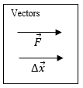 Vector arrows showing the direction of the force from the hand and the displacement of the cart are drawn for you.

* 1. What is the angle between the two vectors? (The angle represents the *difference* in direction of the two vectors)
  2. After it moves a distance of 0.40 m, how much work (in joules) has been done by the force?

1. **Reason and Calculate.** The same cart is rolling along a table and is released. It collides with a block that exerts a 12 N stopping force on the cart. It rolls 0.35 m while stopping.

Vectors

* 1. Draw vector arrows for the block’s force and the displacement of the cart.
  2. What is the angle between the two vectors? What is the work done by the block’s force while bringing the cart to rest?
  3. Interpret the sign of the value for the work that you calculated. What energy flow took place?

1. **Reason and Calculate.** Nowyou push on the cart for 0.50 m while the cart pushes against the block. The block’s force is still 12 N and you push horizontally with a force of 15 N.

FD

* 1. Draw a force diagrams for the system of the cart.
  2. What energy flows are present in this situation?

* 1. Calculate the work done by each force acting on the system.

* 1. What is the total work done on the system? How much kinetic energy did the system gain during this process?

**Net Work – Kinetic Energy Theorem.** The *net work* is the sum of all the work done on the particle. If the net work is positive, the particle *gains* kinetic energy. If the net work is negative, the particle *loses* kinetic energy. This idea is called the *net work - kinetic energy theorem* and is represented by the expression: *Wnet =Ek2 – Ek1 = ΔEk .* Note that this is the same as finding the work done on the particle by the net force vector: *Wnet = |Fnet||Δd| cosθ*.

# Homework: Doing Work! Name:

You are pulling a wagon. It is a bit tiring, but everything is going well until you try to pull it through a patch of mud. The wagon slows and stops. We will focus on the interval while the wagon is slowing in the mud. We will model the effect of the mud on the wagon like a friction force.

1. **Represent**. Draw a force diagram for the system of the wagon.

FD

1. **Describe.** Which forces cause energy to flow in or out of the system?

|  |  |  |  |
| --- | --- | --- | --- |
| Force | θ | Sign of work?  (+, - or 0) | Flow of energy? (in, out or none) |
| *Ft* |  |  |  |
| *Ff* |  |  |  |
| *Fn* |  |  |  |
| *Fg* |  |  |  |

1. **Reason.** Use the new expression for work (*W* = *|F||*Δ*d|*cosθ) to help complete the chart for each force acting on the car.
2. **Reason.** Overall, is the system gaining or losing energy? Explain how you know.
3. **Reason.** Do forces acting perpendicular to the displacement of an object transfer energy in or out of a system? Explain.
4. **Reason.** Did the sign of the work depend on our choice of our positive/negative direction choice? Explain.
5. **Calculate.** The size of your pulling force was 59 N. The friction force from the mud was 75 N. The wagon initially had 8.3 J of kinetic energy. How far did it travel through the mud before stopping?
6. Now you pull the wagon really hard and it starts to speed up.
7. **Reason.** Is this situation accurately described by the FD and energy flow diagram above? Explain what changes you would need to make.
8. **Reason.**  Is the wagon gaining or losing kinetic energy? What would the sign (+/-) of the net work be?
9. **Reason.** How does the amount of energy transferred by each force compare in this situation?

© 2020 C. Meyer

**Doing Work Homework** *(from Irwin Physics 11 p241)*

|  |  |
| --- | --- |
|  |  |
|  |  |
|  |  |

*Answers:* ***12****. 62.5J* ***13****. 0 J* ***14****. 0J* ***15****. 1200 N* ***18a****. 11 000J* ***18b****. 11000J* ***19****. 60000 J*

**Measuring Energy Homework** *(from Irwin Physics 11 p241)*

|  |  |
| --- | --- |
|  |  |

*Answers:* ***29****. 3.00J 18.8J* ***30****. 7.4kg* ***32****. 4.9x105J* ***33****. 57 km/h* ***34****. 3.9x103J* ***35****. 15m/s 30. m/s* ***36****. 7.15J 0.83J 4.95J* ***37****. 1.3x104J 2.7x104J -2.7x103J* ***38****. 75%* ***39****. 1.37x104J 1.75x104J* ***40.*** *7.4 J*

**Homework: Measuring Energy Name:**

## A: Comparing Gravitational Energies Using *Eg* = *mgy*

1. **Reason.** Six objects and their vertical positions relative to a zero-point are shown. Rank the gravitational energies of each object.

**A**

0

*y* =

10 m

**B**

0

*y* =

5 m

**C**

0

*y* =

5 m

**D**

0

*y* =

5 m

**E**

0

*y* =

5 m

**F**

*y* =

0

1 kg

2 kg

2 kg

2 kg

1 kg

1 kg

## B: Comparing Kinetic Energies Using *Ek* = ½*mv*2

1. **Reason.** The velocity and mass of five objects is shown to the right. Suppose *v* = 1 m/s and *m* = 1 kg. Rank the amount of kinetic energy each object has.

*v*

2*v*

*v*

*v*

2*v*

**A**

**B**

**C**

**D**

**E**

4*m*

2*m*

2*m*

1. **Reason.** The velocity and mass of five objects is shown to the right. Suppose *v* = 1 m/s and *m* = 1 kg. Up is positive and down is negative. Rank the amount of kinetic energy each object has.

*v*

*v*

2v

*v*

*v*

**A**

**B**

**C**

**D**

**E**

2*m*

2*m*

## C: Calculating Energies

1. **Reason**. A friend shows you the results of his calculations. (a) Explain what errors he made and (b) correct his work.

|  |  |
| --- | --- |
| *m* = 250 g  *v*1 = 5.0 km/h  *y*1 = 3.4 m | *Eg1 =* *mgy*1 = (250 g)(9.8 N/kg)(3.4 m) = 8330 J  *Ek1* = ½*mv*12 = (0.5)(250 g)(5.0 km/h)2 = 3125 J |

1. **Reason.** Two identical test cars are driving down a test track and hit their brakes at the same position. One car is travelling at twice the speed as the other. (a) Compare the kinetic energies of the two cars. (b) Use the idea of work to explain how much farther the faster car travels while braking.

Answer: C#1 Eg1 = 8.33J and Ek1 0.241 J

# Changes in Gravitational Energy

When objects move vertically energy flows in or out of Earth’s gravitational field. Let’s follow these flows and learn how to model the energy transfers in the system.

## A: The Ball Drop and Kinetic Energy

You will drop a basketball through a displacement of your choice (between 0.5 and 1.2 m) and examine the energy changes.

Ek1 + Eg1+ Wext= Ek2 +Eg2

+

0

-

Sketch

1. **Represent.** Draw a sketch of a ball falling. Event 1 = the ball is released. Event 2 = the ball contacts the ground. Label the two vertical positions *y*1 and *y*2 (one of these should be the zero-point). Complete the bar chart for the **earth-ball** system.

Work-Energy Equations. Our bar charts help us to think about energy and to construct an equation that relates the energy of a system at two moments in time. The total energy of a system at one moment plus any work equals the total energy of a system at another moment: *ET1 +Wext = ET2*. This is called a *work-energy equation* for the system. The bar chart helps us to decide which energies to include in each total. If a particular energy is zero, we don’t bother including it.

1. **Represent.** Construct a work-energy equation for the earth-ball system.
2. **Calculate.** Complete your work-energy equation by replacing each energy symbol with its mathematical expression, including event numbers. For example, *Eg*1 is replaced with *mgy*1.
3. **Calculate.** Use your new work-energy equation tofind the speed of the ball when it contacts the ground. In other words, rearrange your equation from #3 to isolate *v*2. Something neat will happen!
4. **Test.** Use the motion detector to measure the speed of the ball when it contacts the ground.
5. **Evaluate.** How does your measured value for the speed compare with your prediction? What might be responsible for a small difference?

© 2020 C. Meyer

## B: The Ramp Race

**1**

**2**

Ball

A

Ball

B

Your teacher has two tracks set up at the front of the class. One track has a steep incline and the other a more gradual incline. Both start at the same height and end at the same height. Friction is very small and can be neglected. There are two important events: (1) Ball A and B are released, (2) Each ball reaches the end of the track.

1. **Predict**. Which ball do you think will reach the end of the track first? Explain why you think this.
2. **Observe**. Which ball won the race? Explain why this happened.
3. 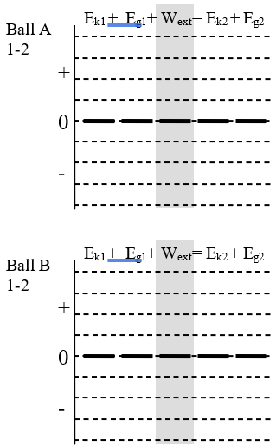**Predict**. Which ball do you think will be travelling faster when it reaches the end of the track? Explain why you think this.
4. **Observe**. Which ball was travelling faster? We’ll try to explain this using energy bar charts.
5. **Reason.** What energy changes take place as the ball travels down the incline?
6. **Represent.** Complete an energy bar chart for each ball for the interval 1-2.
7. **Explain.** Use your energy bar charts to explain the result from #4 above.

1. **Reason.** Albert says, “I don’t understand why ball B wins the race. They both end up traveling roughly the same distance and ball A even accelerates for more time! It should be faster!” Based on your observations and understanding of energy, help Albert understand.

**Path Independence.** The amount of energy the flows in or out of the gravitational field **does not depend on the path** taken by the object. It only depends on the object’s change in vertical position (displacement). The property is called *path independence* – any path between the same vertical positions will give the same results. This happened because gravity does no work on an object during the horizontal parts of the object’s motion.

**Homework: Changes in Gravitational Energy Name:**

The value for the gravitational energy depends on the choice of the zero-point. If two people choose a different zero-points, will their calculations predict different things? Let’s see!

1

2

Zero-point A

+y

*y*1 = 15 m

*y*2 = 5 m

0

Zero-point B

+y

*y*1 = m

*y*2 = 0 m

A 100 kg rollercoaster cart rolls down a curving track. It starts from rest at the top. We will examine two moments in time: (1) at the top of the track and (2) part way down. **System = cart, Earth**

1. Find the value of *y*1 using zero-point B.

Ek1 + Eg1+ Wext= Ek2 +Eg2

+

0

-

Ek1 + Eg1+ Wext= Ek2 +Eg2

+

0

-

Equation:

Equation:

1. **Represent.**
2. Draw an energy bar chart for each zero-point.
3. Construct a work-energy equation for the system for each zero-point.
4. **Calculate.** Complete the chart below.Calculate the gravitational energies of the system according to each zero-point. Use these energies to determine how much kinetic energy and speed the cart has a moment 2.

|  |  |  |  |  |
| --- | --- | --- | --- | --- |
|  | *E*g1 | *E*­g­2 | *E*k2 | *v*2 |
| Zero-point A |  |  |  |  |
| Zero-point B |  |  |  |  |

1. **Explain.** Use both the calculations and the bar charts to explain why the choice of zero-point did not affect the results of the calculation.

**Changes in Gravitational Energy.** Only *changes* in gravitational energy affect predictions using energy techniques. That is why we can set any vertical position as the zero-point. The vertical displacement of the object does not depend on the choice of origin and therefore the *change* in gravitational potential energy does not depend on it either!

© 2020 C. Meyer

**The Conservation of Energy**

## A: The Behemoth

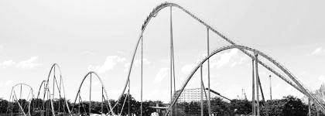A recent rollercoaster at Canada’s Wonderland is called “The Behemoth” due to its 70.1 m tall starting hill. Assume the train is at rest when it reaches the top of the first hill. We will compare the energy at two moments in time: 1 = at the top of the first hill and 2 = at ground level after the first hill.

1. **Represent.** Choose a zero-point for gravitational energy. Label on the photo the vertical positions *y*1 and *y*2.
2. **Represent.** Draw an energy bar chart for the earth-train system. Write down a complete work-energy equation that relates the energies of the system at moment 1 with moment 2. Only write down the energy terms that are not zero.

Ek1 + Eg1+ Wext= Ek2 +Eg2

+

0

-

Work-Energy Equation

1. **Calculate.** Use the energy equation to find the speed of the rollercoaster at moment 2 in km/h.

1. **Reason.** In reality, the train reaches the bottom with a speed of 125 km/h. Why is our model not giving the proper result?

Thermal Energy. When two objects slide against another, energy is transferred into *thermal energy* (*Eth*) due to a friction interaction. The two sliding objects will warm up, which means the thermal energy is shared between them.

1. **Calculate.** Use the train mass, *mt =* 2.7 x 103 kg to determine the amount of energy the train lost due to friction in the form of thermal energy. You’ll need to compare the amount of kinetic energy the train was supposed to have at the bottom with what it actually had.

Answer: *v*2 = 14 m/s??

## B: The Glebe Flyer

Rumour has it that a rollercoaster is going to be built in our school’s courtyard. Plans leaked to the media show a likely design. The train starts from rest at moment 1 located 45 m above the ground. At moment 2 it is located 10 m above the ground. For all our calculations, we will assume that the force of friction is negligible.

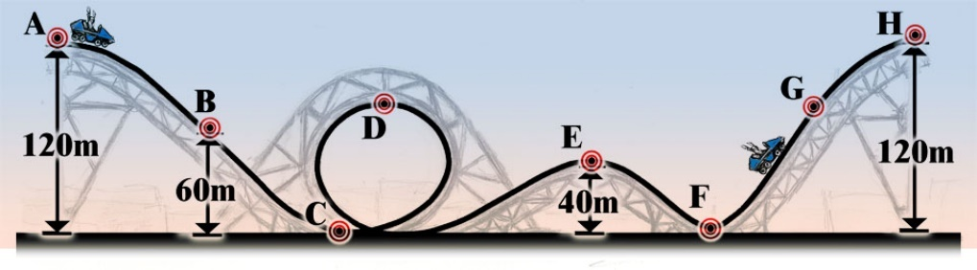

1

2

3

4

5

1. **Solve.** Complete the diagram and chart. Determine the rollercoaster’s speed at moment 2.

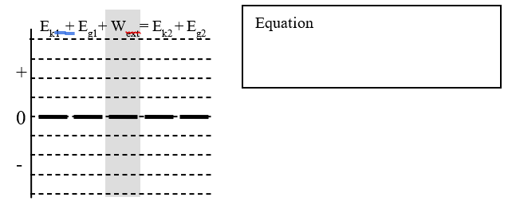

1. **Solve.** When the cart is at the top of the loop-de-loop its speed is 17.0 m/s. How tall is the loop-de-loop? Use the energy bar chart to help.

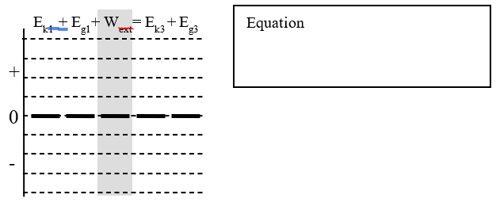

**Homework: The Conservation of Energy Name:**

1. **Reason.** A block is attached to a rope so you can raise or lower it vertically. An energy bar chart illustrates the energies at two moments in time while it is being raised or lowered.
2. Use the bar chart to explain what is happening to the speed and position of the block.
3. State the direction of energy flow, and write a complete work-energy equation for each interval.

Δ*y*

*Ft*

|  |  |  |
| --- | --- | --- |
| +  0  -  Ek1 + Eg1+ Wext= Ek2 +Eg2  Explain:    Flow:  Work-Energy Equation: | +  0  -  Ek1 + Eg1+ Wext= Ek2 +Eg2  Explain:    Flow:    Work-Energy Equation: | +  0  -  Ek1 + Eg1+ Wext= Ek2 +Eg2  Explain:    Flow:    Work-Energy Equation: |

1. **Represent and Calculate.**  You throw a 200 g ball upwards. It leaves your hand with a speed of 10 m/s. We choose a vertical origin at the vertical position where the ball is released from your hand. We examine three moments in time: (1) it leaves your hand, (2) it is halfway up, and (3) it is at its highest point.
2. Draw a motion diagram and label these moments.
3. For each moment in time, complete an energy bar chart for the earth-ball system.
4. Calculate the energies at each moment and find the total energy of the system. Show your work.

|  |  |  |  |
| --- | --- | --- | --- |
| Motion Diagram  0  + *y* | Ek1  Eg1  +  0  -  *Ek1* =  *Eg1* =    *ET1 =* | Ek2  Eg2  +  0  -  *Ek2* =  *Eg2* =  *ET2 =* | Ek3  Eg3  +  0  -  *Ek3* =  *Eg3* =  *ET3 =* |

1. How does the total energy compare at each moment in time? Does this make sense?

**Conservation of Energy Homework** *(from Irwin Physics 11 p241)*

|  |  |
| --- | --- |
|  | Answers: **41**. Ek2=2600J Eg2=2000J **42**. 31. m/s  **43**. 2.59 m **44**. 24.5 m/s |

© 2015 C. Meyer

# Representing Conservation of Energy

1. **Represent.** A car is speeding along Carling Avenue. It begins to travel up a hill when the driver spots an accident ahead and slams on the brakes. The car skids and quickly stops part way up the hill. State the energy flow, complete the work-energy bar chart and equation for this situation. Be sure to add in the energy labels to the bar chart.

Flow:

Work-energy equation:

1. **Represent.** A ski resort uses a motor and a rope to pull beginning skiers up a small hill. At event (1) the skier is starts at rest at the bottom of the hill. He grabs the rope, and at event (2) is moving with a constant speed near the top of the hill. Complete an energy flow diagram, work-energy bar chart and equation for this situation.

Flow:

Work-energy equation:

© 2017 C. Meyer

# Lesson 6: Power

Winning a sprinting race is all about transferring as much energy as possible in the least amount of time. The winner is often the most *powerful* individual.

Power*. Power* is a ratio of the amount of energy transferred (Δ*E)* to the time taken (Δ*t*): *P =* Δ*E /* Δ*t*. If that energy transfer is due to work, then Δ*E* = *W*. The S.I. unit for power is the *watt* (W) where one watt of power means one joule of energy transferred for each second of time (1 W = 1 J/s).

## A: The Stair Master

Let’s figure out our leg power while travelling up a flight of stairs. We chose two events: (1) at rest at the bottom of the stairs, and (2) at rest at the top of the stairs.

1. **Reason.** Describe the energy changes that take place between events 1 and 2. *E*c represents an amount of chemical energy stored in your muscles.

1-2

0

-

+

0

-

Ek1 + Eg1+ Ec1 + Wext= Ek2 +Eg2

1. **Represent.**  Complete an energy flow diagram and bar chart for the interval 1-2. What is the system?
2. **Reason.** To calculate your *power*, you need to identify the change in energy, Δ*E*, that you will use. There are two important changes in energy in this situation: Δ*Ec* and Δ*Eg*. Which of these best represents a change in energy involved with your power *output*?
3. **Represent.** Draw asketch showing events 1 and 2. Be sure to label *y*1, *y*2, *v*1, and *v*2 in your sketch. Label any other quantities you will measure to find your power.
4. **Observe.** Gather the equipment you will need for your measurements. Travel up a flight of stairs at a modest pace (but don’t run, we don’t want you to fall!) Record your measurements on your diagram.
5. **Calculate.** Compute your leg power in watts (W) and horsepower (hp) where 1 hp = 746 W. Show your work. How does this compare to your favourite car? (2020 Honda Civic = 158 hp)

## B: Back to the Behemoth!

1. **Solve.** The trains on the Behemoth start at rest from at the loading platform (we’ll call this h = 0 m) and are pulled to the top of the first hill by a motor. At the top, 60.1 m above the platform, the train has a speed of 1.7 m/s. Along the way, the train experiences a frictional force of 3724 N over a 99 m distance along the track.   
   a) How much energy does the motor provide to the 2700. kg train to achieve this? Use the energy bar chart to help.  
   b) How much horsepower does the motor need if it does this work in 67 s?

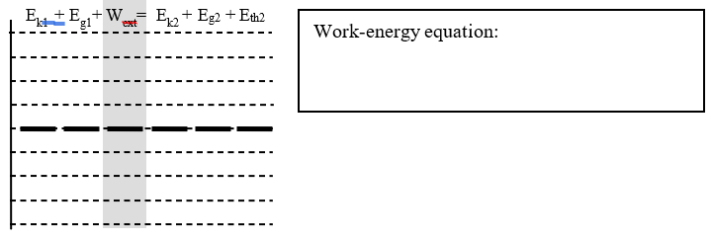

## C: He’s Got the Power

1. **A Powerful Run.**  Usain Bolt is able to reach a top speed of 44.72 km/h by the 65-m mark of a 100-m race. This took him about 6.3 seconds. He has a mass of 96 kg. He accomplishes this by transferring energy stored in chemicals in his legs into kinetic energy. We will explore his ability to change chemical energy to kinetic energy using two models.
2. **Model #1: 100% Efficient.** Let’s begin by assuming that all Bolt’s chemical energy is transferred to kinetic energy. Draw an energy bar chart showing the transfer of energy. What is his power while he is accelerating to his top speed?

Ek1 + Ec1+ Wext= Ek2

1. **Model #2: Thermal Losses.** Unfortunately, the human body is not perfectly efficient like our chart above suggests. Quite a bit of chemical energy becomes thermal energy. Let’s assume that his muscles are 50% efficient at transferring chemical energy to kinetic energy. Draw the bar chart for this revised situation. How much energy does Bolt use to achieve his result?

+

0

-

Ek1 + Ec1+ Wext= Ek2 + Eth

© C. Meyer, 2017

**SPH3U: Thermal Energy & Specific Heat Capacity**

1. Use the diagram of *temperature of a 1kg block of ice* to answer the questions below

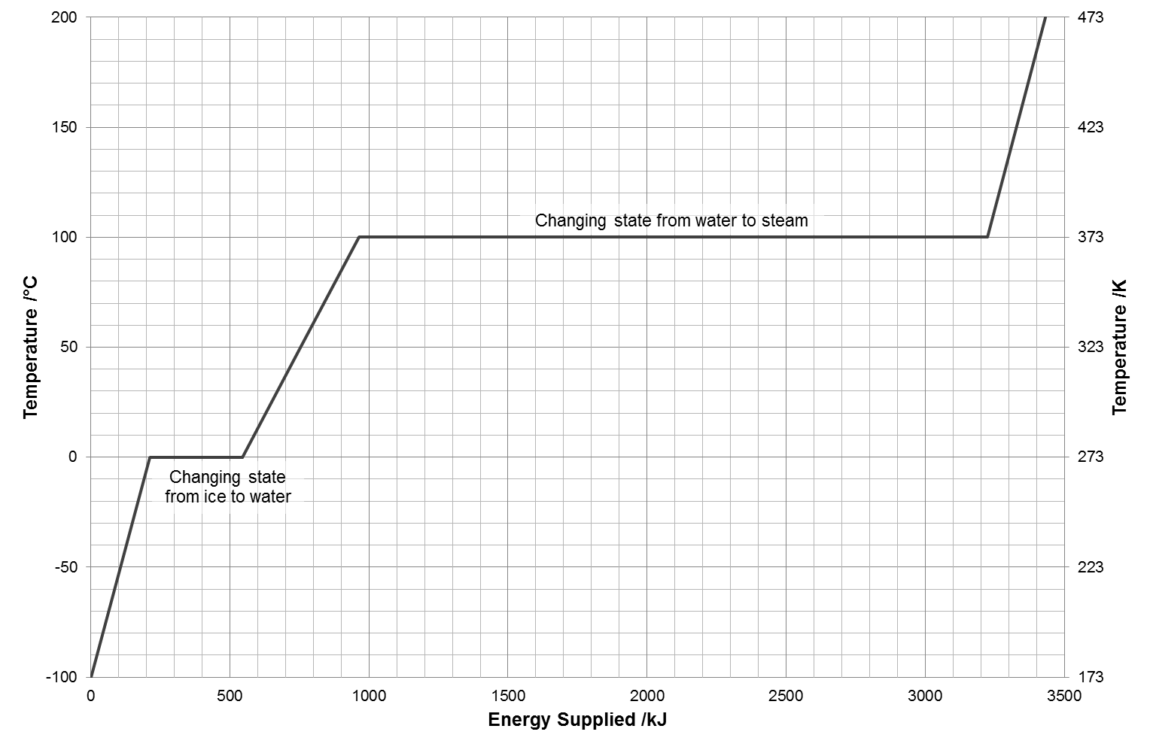

*From http://wordpress.mrreid.org/2012/09/27/specific-heat-latent-heat-and-scalds/*

*The plateau at 0°C is when solid water (ice) is changing into liquid water (water).*

* 1. What does the higher plateau represent? __________________________________________
  2. At what temperature does the second plateau occur? ___________________________________ . Use this information to add a temperature scale (°C).
  3. Correctly place the following terms on the diagram: ***solid, liquid, gas***.
  4. Use the graph to find the amount of energy required (*ignore change of states*) to raise the temperature of

|  |  |
| --- | --- |
| i) 1 kg of water from 0°C to 100°C? | iii) 1 kg of ice from -100°C to 0°C? |
| ii) 1 kg of water only 1°C? | iv) 1 kg of steam from 100°C to 200°C? |

***Specific heat capacity****, c, is the energy required per unit mass to raise the temperature.*

*cwater = 4.2 cice =2.1  cvapour = 2.0 *

*The specific heat capacity c is used in the equation:*

*EH=mcΔT where EH = heat energy*

*m = mass*

*c = specific heat capacity*

*ΔT = change in temperature*

* 1. Compare your answers from question (d) to the specific heat capacities of water, ice and vapour.

1. Use the graph and/or the equation to find the change in temperature of a **2.0 kg** sample of water that absorbs 200 kJ of energy.
2. Use the graph to find the energy required to change the state
   1. 1 kg of ice to water @ 0°C b) 1 kg of water into steam @ 100°C

*The* ***latent heat*** *of a substance is the energy needed to change the state of a substance.* ***Latent heat of fusion*** *is the energy required to change solid water (ice) into liquid water: Lfusion= 330 kJ/kg*

*The* ***latent heat of vaporization*** *is the energy required to change water into water vapour: Lvaporization= 2300 kJ/kg*

Use the graph or the equations to answer the following questions

|  |  |  |
| --- | --- | --- |
| 1. How much energy is needed to vaporize 3kg of liquid water at 100°C into 3kg of water vapour at 100°C? | 1. How much energy is needed to increase the temperature of 1kg of liquid water from 10°C to 75°C? | 1. A glass of water absorbs 50 kJ of energy and its temperature increases by 12°C, what mass of water was used? |

|  |  |
| --- | --- |
| 1. How much energy is required to melt a 75 kg snowman (from -10oC ice to 0oC water)? | 1. How much energy is needed to change 500g of ice at –20oC into steam at 120oC? |

*Answers:* ***7****. 2625 kJ* ***8****. 1566 kJ*

**Energy Transfer – including power**

**1. Represent.** The engine of a car transfers the energy stored in gasoline into thermal energy and kinetic energy of the vehicle. In a typical car, only 20% of the energy stored in the gasoline becomes kinetic energy. At moment 1, the car has 1 L of gasoline in its tank. At moment 2, that amount of gasoline has been consumed.

1-2

Work-energy equation:

1. **Solve.**  Complete question #2 above. A 57 kg skier is pulled up the hill at a speed of 1.1 m/s. The top of the hill is 13.7 m above the bottom. A trip up the hill takes 23 seconds. What is the power output of the motor while pulling this skier?

**Heat Energy Homework** *(from Irwin Physics 11 p276)*

|  |  |
| --- | --- |
| **29.** A 25.0g piece of iron, originally at 500C has its temperature fall to 100C when it is placed in a cold water bath. How much energy was lost by the piece of iron during the cooling process? | **24**. 336 kJ/kg **26**. 108C **28**. 55.1C 4.76C **29**. 4.6 kJ **31**. 2.87 kg **32**. 11.9L **33**. 2.0 kJ/kg **34.** 25kJ/kg 25kJ **36**. 396 kJ **37**. 645 kJ **38**. 622 kJ |

**SPH3U: Energy Problem Set Name:**

**Energy Transformations, Work and Conservation of Energy**

1. A 50.0kg cyclist on a 10.0kg bicycle speeds up from 5.00 m/s to 10.0 m/s in 2.50 seconds. How much work was done by the cyclist? *W=2250J*
2. A person throws a rock from an 85.0 m cliff overlooking the ocean, with an initial velocity of 18.0 m/s [up]. Find the max height of the ball and the velocity of the ball right before it hit the water below the cliff.

*hmax=101.2m v3=45.0m/s [down]*

1. A person lifts up a 1.00 kg block from the ground to a height of 2.00 m before releasing it. The block continues travelling another 8.00 m before coming to rest and returning back to the ground. Using the work-energy theorem, calculate the energy of the block and the velocity of the block at each of the events: (1) on the ground (2) at a height of 2.0m (3) at max height (4) halfway down (5) block right before it hits the ground.

Eg1=Ek1=0 v2=12.7 m/s Eg2=20.0J Ek2=80.0J Eg3=100. J Ek2=0J Eg4=Ek4=50.0J v4=10.m/s

Eg5=0K Ek5=100. J v5=14.1 m/s [down]

1. A person is pulling a 15.0 kg box across the floor with a force of 65.0 N [32.0º above the horizontal] for a total displacement of 5.00m (The applied force is equivalent to 55.1N [horizontally] and 34.4 N [vertically]). The coefficient of friction between the box and the ground is *μk*=0.250. Find
   1. the normal force FN=116 N
   2. the acceleration of the box a=1.75 m/s2
   3. the work done by each of the forces WFa=276J WFf= -145J WFnet=131J

WFn=WFg=0J

* 1. the final velocity of the box v2=4.18 m/s

A

B

C

D

E

68m

34m

17m

15m

1. A 100.0 kg cart starts at point A at 2.00 m/s (68.0m off the ground) on a smooth rollercoaster.
   1. Find the speed of the rollercoaster at point B, 17.0m off the ground.
   2. Find the breaking force required to stop the cart in 15.0m if the brakes are applied at point D
   3. Find the coefficient of kinetic friction

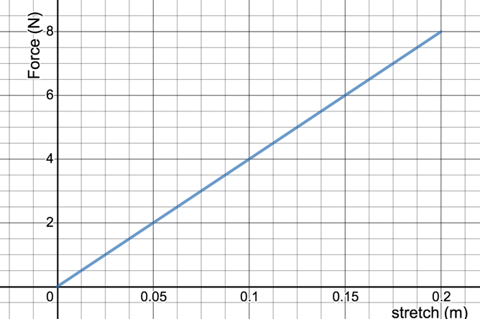*vB=32.0 m/s Fbreaking=4547 N* µ=4.55

1. An elastic band is stretched 20.0 cm in order to launch a 14.0g rubber stopper vertically upward.
   1. How much energy is stored in the elastic band?
   2. How high will the rubber stopper rise above the launch height

**Power and Efficiency**

1. Several friends use a simple rope and pulley to raise a tree house from the ground into a tree. The mass of the tree house is 150 kg. By pulling together, the friends manage to exert an average force of 1.6 x 103 N as they raise the tree house a distance of 3.2 m above the ground.
   1. Find the work done in the raising the tree house. (*5.1x103J*)
   2. How much “useful work” is done? (*4.7x103J*)
   3. What is the efficiency of the rope and pulley is raising the tree house? (*92%*)
   4. Suggest why the efficiency of this simple machine is not 100%.
2. A farmer is contemplating using a small waterfall on his property for hydroelectric power generation. He collects data, and finds that 3000 kg of water fall 15.0 m every minute. Assuming the highest possible efficiency that he is able to achieve in transforming the water’s gravitational potential energy to electric energy is 74%, what continuous power in Watts could he generate? (*5.4x103W*)
3. A container factory uses 370 W motor to operate a conveyor belt that lifts containers from one floor to another. To raise 250 kg a vertical distance of 3.6 m, the motor runs for 45 s.
   1. Determine the useful energy output. *(8.8kJ)*
   2. How much energy does the motor use? *(17kJ)*
   3. What is the efficiency of the motorized conveyor system? *(53%)*
4. A 1.5 kW water pump is used to empty a swimming pool. It drains a 100 000 L swimming pool by lifting the water from the bottom to a drain hose on the pool deck 3.06 m above the bottom. If the pump was running for 3.5 hours, find the efficiency of the pump. Note that the intended output of the pump is to lift water and 1 L of water has a mass of 1 kg. (*from oerb*) *(15.9%)*

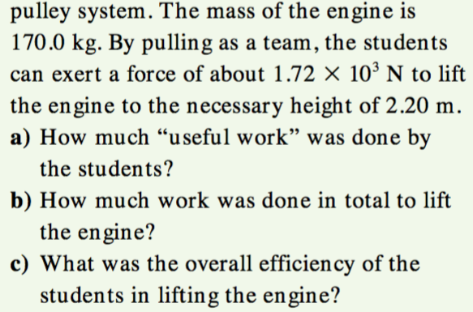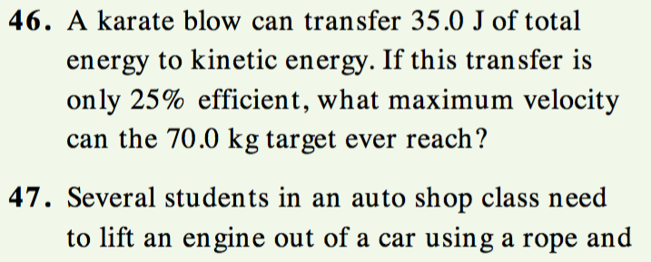

**Thermal Energy**

caluminum=9.1x102 cethyl alcohol =2.4x102 ccopper=3.9x102csand=8.0x102

cmercury=1.4x102 ciron=4.6x102 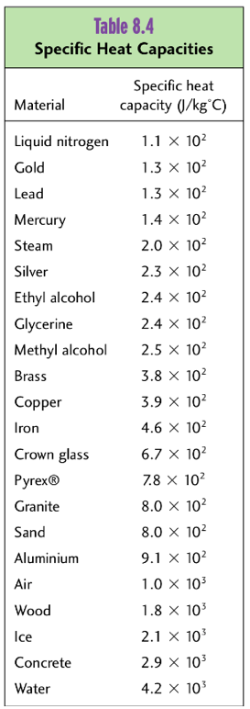

1. A 21 kg aluminum block absorbs 1.5x105 J of energy. Calculate the change in temperature. (7.8°C)
2. 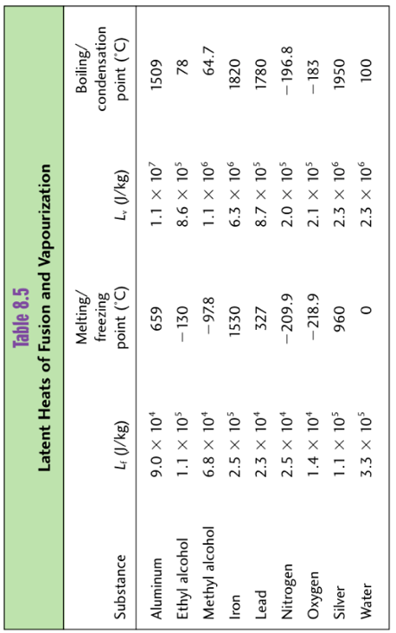After 2.0 kg of mercury gained 2.52 x 104 J of heat energy, its final temperature was 130 °C. What was its initial temperature?
3. Calculate the energy required to melt a 4.0 kg block of ice initially at -20.0°C. (The final temperature of the water is 0°C) EH=1488 kJ

**Energy Research & Artifact Project**

***Artifact: an object made by humans with cultural, social or historical significance***

In this independent project you need to create some kind of artifact connected to an energy-related topic or issue of your choice. You will be given a great deal of freedom to choose the type of artifact you create, and you will have one full day to work on it. Some examples include:

|  |  |  |  |  |  |
| --- | --- | --- | --- | --- | --- |
| A poster | A video | A song/rap | An essay/written analysis | | A story |
| A diorama | A piece of art | A poem | An interpretive dance | | A pamphlet/brochure |
| A dramatic production | | Public service announcement | | Feel free to suggest other options… | |

Your artifact can be either informative or persuasive.

Trying to convince people about the merit of an idea (or lack thereof). Can be one-sided/biased.

Trying to educate people about the issue. Can include both sides of the argument (pros/cons).

Some other comments & considerations…

* Yes, you are expected to do some research into your topic
* Artifacts that are primarily visual in nature (ex. a painting) should be accompanied by a brief written explanation describing what the artifact is intending to demonstrate/communicate.
* You will be given one full day at home this week to complete your project
* Artifact can be submitted this week (Oct 23) or when we return for our final week (Nov 2)
* Although you can use any resources you wish, your artifact must contact value added by you. For example, simply making a slideshow of pictures from the internet would not be ok…but assembling those pictures in a creative/artistic/impactful way would be ok
* This is intended to be complete in a day, not over the full upcoming week. **I will keep my expectations reasonable!!**

I will be marking this project according to the following criteria:

|  |  |  |
| --- | --- | --- |
| ***Evidence/quality of research & learning*** | ***Effectiveness to inform/persuade*** | ***Overall impression*** |

Learn

Have funf

Be creative

Some possible topic ideas: (more ideas to come)

|  |  |  |
| --- | --- | --- |
| Pipelines – are they really that bad? | First Nations – are they benefitting enough from the energy industry? | Energy in developing countries – how does it work? |
| Hydroelectricity - what impact do dams have on people & environment? | Buying local – is it really energy efficient? | Air conditioners – comfortable yes, but what’s the impact? |
| Geothermal energy – why isn’t there more of it? | Solar panels – can they be improved? Energy cost to build? | Emails – what’s the energy/environmental cost? |
| Why are renewable energy sources still way behind non-renewable | Incandescent vs. fluorescent vs. LED lights – what’s it all about? | Wind turbines – ugly eyesore or energy source of the future? |
| Biomass, tidal energy – what’s it all about? | Energy storage – is it a good idea? | Living “off the grid” – how does it work from an energy point of view? |
| Household heating & cooling - | Vegetarianism – the energy efficient way to live? | COVID – what’s been its impact on the energy sector? |
| Oil & gas – shutting it down would put many out of work | Energy use in other countries – what can we learn from them? | Canada’s energy attitudes – regional differences/conflict |